Introduction to Learning Theories
AURA Teaching Course 1

Course Pack
February, 2016

About the African Universities’ Research Approaches (AURA) Capacity Development Programme

The African Universities’ Research Approaches Programme (AURA) sought to strengthen research and teaching practices in East Africa through a blended learning approach – mixing online and face to face courses. AURA, a two-year programme, funded by UK AID, was implemented from November 2014 to September 2016 by the project consortium, consisting of: the Institute of Development Studies (IDS), the Information Training and Outreach Centre for Africa (ITOCA), and Loughborough University.
The overarching aim of the programme was to address continent-wide goals to support African universities to co-create a context-specific educational framework that would: address the need for locally generated research knowledge by skilled researchers (and graduates); and support faculty to nurture strong research and information capabilities by modelling how to create research-rich, and pedagogically innovative, teaching and learning environments.
AURA completed the following deliverables:
- The co-development of three research capacity courses that provided targeted support to academics (and students) to design, develop, and peer review, 5 responses to ‘live’ research calls, and strengthen current post-graduate research proposals
- Two teaching courses that strengthened capacity to design people-centred and technology-enhanced learning environments using evidence-informed teaching practices
- Application was a key aspect of the educational framework, and all participants were required to demonstrate comprehension of the course content through assessed course assignments, dialogic tasks and the development of curriculum enrichment plans.
- The programme took a cross-organisational approach by working with academics, technical and administrative staff in multi-disciplinary teams (called the ALIRT teams) to identify how to cost-effectively implement and support the achievement of institutional goals

The following educational framework is available to download through a creative commons license as individual course packs:
Three research courses:
- Orientation to different research approaches – known as R1
- Orientation to ‘researcher-led’, analytical research approaches - known as R2
- Research communications in social media – known as R4
Two teaching courses:
- Introduction to Teaching and Learning theory – known as T1
- Technology-enhanced learning approaches – known as T3
All of the course packs are aimed at educators in higher education institutions primarily in Africa but are also applicable to educators and other training/service providers in other parts of the world. Resources are can be re-used, adapted, or remixed (where indicated by the license) as long as the resulting materials are fully attributed.
AURA, a two-year programme, funded by UK AID, was implemented from November 2014 to September 2016.
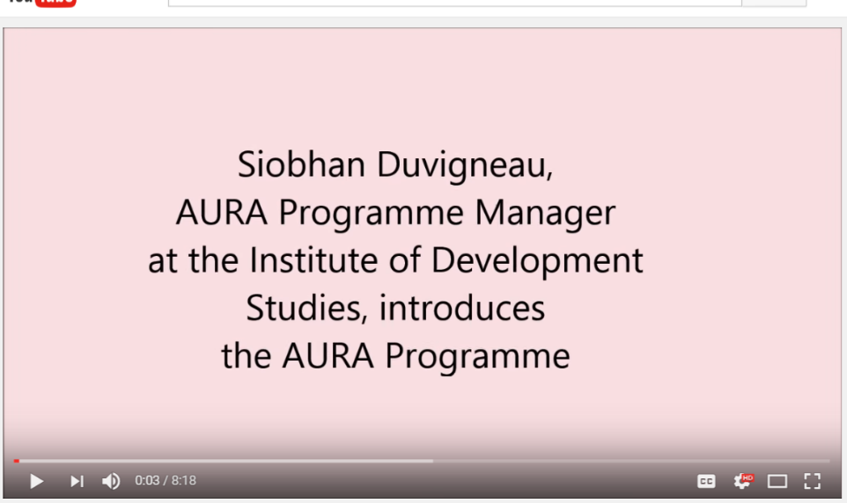
To watch the video [T1-V01], please click here: https://youtu.be/Yho7JFDwrpg
Siobhan Duvigneau, AURA Programme Manager, provides an introduction to the AURA Programme, to the consortium partners and participating partners from East Africa, and gives an overview of the aims and rationale of the programme.

The AURA Programme Consortium and Partners

The AURA Programme, led by the Institute of Development Studies in partnership with the Information Training and Outreach Centre for Africa and Loughborough University, worked with four universities - Jimma University, Kenyatta University, Muhimbili University of Health and Allied Sciences (MUHAS) and Strathmore University, and was aimed at academics working in health, business and other academic disciplines.

Acronyms

ALIRT | Academic department, Library, ICT Services, Research unit and Teaching unit
AURA | African Universities’ Research Approaches Programme
T1_D1-S1 | Teaching Course One-Day 1-Session 1
IDS | Institute of Development Studies, UK
ITOCA | Training and Outreach Centre for Africa
LMS | Learning Management System
LO | Learning Outcome
R1 | Research Course One
R4 | Research Course Four
T1 | Teaching Course One
T1-H01 | Teaching Course One-Handout 01
T1-P01-S1 | Teaching Course Three -PowerPoint Presentation 01-Session 1
T1-R01 | Research Course One-Reading 01
T1-V01 | Teaching Course Three-Video 01
T3 | Teaching Course Three

List of Resources

Course Overview
Resource Unique Identifier | Title & Description
T1_Course Overview | Overview: AURA Teaching Course 1 (T1).
T1-V01 | Resource: Siobhan Duvigneau introduces the AURA Programme (course overview). Siobhan Duvigneau. AURA Programme Manager, provides an introduction to the AURA Programme, to the consortium partners and participating partners from East Africa, and gives an overview of the aims and rationale of the programme.  [Link: https://youtu.be/Yho7JFDwrpg]

Face to Face Activities
Resource Unique Identifier | Title & Description
T1_D1-S1 | Session 1 Face to Face Course (Day 1): Session Plan. Guidance notes for facilitators/educators.
T1-P01-S1 | Power Point Presentation Session 1: Introduction to the Course and its Outcomes. This presentation provides an introduction to the course objectives, the ice-breaker activity, the rules of the course, and the formative assessment technique (i.e. mood monitor) used during the course.
T1_D1-S2 | Session 2 Face to Face Course (Day 1): Session Plan. Guidance notes for facilitators/educators.
T1-P02-S2 | PowerPoint Presentation Session 2: Experiencing Learner-Centred Training Approaches. This presentation clarifies the learning outcomes of the session, and provides guidelines and resources for two experiential activities that will enable learners to identify key characteristics of the constructivist/socio constructivist learning theories, and to produce a key resource on the four main learning theories presented.
T1_D1-S3 | Session 3 Face to Face Course (Day 1): Session Plan. Guidance notes for facilitators/educators.
T1-P03-S3 | PowerPoint Presentation Session 3: Learning preferences and styles  This presentation outlines the learning outcomes of the session, and provides guidelines and prompting questions for the individual and group activities. This session introduces the learner to Sfard’s research on adopting a mixed-methods teaching approaches (1998). The session also investigates the ways individuals prefer to learn and reflects on the impact learning preferences or styles may have on the design and delivery of educational courses. Although learning preferences/styles is a highly contested area, it is useful to explore the range of ways people learn as this will inform the educator’s decisions about the most appropriate and relevant learning design.
T1-H01 | Handout Session 3: Trainer Scenarios: Educator A and B  This handout explores different teaching styles by presenting scenarios of educators who adopt teacher-led and student-led teaching practices. The purpose of this handout is to stimulate discussion around teaching style.
T1-V02 | B.F. Skinner - Operant Conditioning and Free Will (video).  This video shows Burrhus.F. Skinner’s operant conditioning chamber and his philosophy of science called Radical Behaviourism. As a resource this video is intended to stimulate discussion about Behaviourist learning theories, and schedules of reinforcement.  [Link: https://www.youtube.com/watch?v=yhvaSEJtOV8]
T1-V03 | Thorndike’s puzzle box (video).  A video showing Edward L Thorndike’s work on operant conditioning (known as Thorndike’s Law of Effect). As a resource this video is intended to stimulate discussion about Behaviourist learning theories.  [Link: https://www.youtube.com/watch?v=BDujDOLre-8]
T1-V04 | Piaget's Developmental Theory- an Overview (Davidson FIlms, Inc.) (video).  This video provides an overview of Jean Piaget’s developmental theory. As a resource this video is intended to stimulate discussion about Cognitivist learning theories.  [Link: https://www.youtube.com/watch?v=QX6JxLwMJeQ]
T1-V05 | PIDP3106 - Scaffolding Instructional Strategy by Dominique (video)  This videos provides an overview of Scaffolding, an instructional strategy developed by Jerome Bruner – a psychologist who made significant contributions to cognitive learning theory.  [Link: https://www.youtube.com/watch?v=tF3aTutj6a4 ]
T1-V06 | Vygotsky's Developmental Theory: An Introduction (Davidson Films, Inc.) (video).  This video provides an overview of Lev Vygotsky’s work, which is associated with Constructivist learning theory and the importance of the social context and language in learning contexts.  [Link: https://youtu.be/InzmZtHuZPY?list=PLmPERF6_BKqroJMdA11OkZ64OjosjAl-J]
T1-V07 | Siemen's Socializing Open Learning (video & transcript).  This video presents George Siemen’s theory on Connectivist, Socializing Open Learning approaches. As a relatively new concept this video presents a learning theory relevant to digital learning environments and 21st Century skills.  [Link: https://www.youtube.com/watch?v=rqL_lsogeNU]
T1-R01 | Resource Session 3: “Connectivism: A Learning Theory for the Digital Age” by George Siemens.  A milestone article by George Siemen’s, which presents a Learning theory for the digital age entitled Connectivism.  [Link: http://www.itdl.org/journal/jan_05/article01.htm]
T1-H02 | Handout Session 3: Learning Theory Activity Table  This learning resource enables participants to capture their insights about the characteristics, related activities and limitations of each learning theory (i.e. Behaviourism, Cognitivism, Constructivism and Connectivism). These individual or peer insights are shared and discussed as a group activity.
T1-R02 | Resource Session 3: Sfard “On Two Metaphors for Learning,” 1998  This paper is available for download from the author’s academia.edu page (see the link below). This resource presents a case for mixed modalities in teaching practices (defined as the acquisition and participation metaphor). This article is provided as background reading for the course facilitator/educator.  [Link: https://www.academia.edu/19260370/On_Two_Metaphors_for_Learning_and_the_Dangers_of_Choosing_Just_One]
T1_D1-S4 | Session 4 Face to Face Course (Day 1): Session Plan. Guidance notes for facilitators/educators.
T1-P04-S4 | PowerPoint Presentation Session 4: Collecting learning assessment data  This presentation outlines the learning outcomes of the session, and provides guidelines and prompting questions for the individual and group activities. The purpose of this session is to outline the importance of carrying out continuous learning assessment. The session makes a distinction between formative and summative data assessment methods (the when) and explains their relevance. Furthermore it also points to differences between the wide variety of things to measure (the what) and the different ways of going about it (the how). The session ends with a practical focus: it gets learners into designing their own survey and then leaves them with a set of good practice guidelines for their work.
T1-H03 | Handout Session 4: Student satisfaction survey  This handout provides an example of a student satisfaction survey for individual/group discussion.
T1-V08 | Likert Scale (video).  Jagdeep Shokar, Monitoring and Evaluation Advisor at the Institute of Development Studies (IDS), talks about the use of Likert scales in surveys.  [Link: https://www.youtube.com/watch?v=q3FnFTJ528s ]
T1-V09 | Plausibility (video).  Jagdeep Shokar, Monitoring and Evaluation Advisor at the Institute of Development Studies (IDS), talks about the importance of plausibility in multiple choice questions. The video is taken from observations on a badly designed survey instrument, available on the AURA course packs page.  [Link: https://www.youtube.com/watch?v=NXvmkTC9rcA ]
T1-V10 | Demographic Data (video).  Jagdeep Shokar, Monitoring and Evaluation Advisor at the Institute of Development Studies, talks about the importance of collecting demographic data in research.  [Link: https://www.youtube.com/watch?v=hdRaMg3hBtk]
T1_D1-S5 | Session 5 Face to Face Course (Day 1): Session Plan. Guidance notes for facilitators/educators.
T1-P05-S5 | PowerPoint Presentation Session 5: Reflective Practices.  This presentation outlines the learning outcomes of the session, and provides activities to introduce learners to reflective practices and to writing reflective journals, which is a compulsory task required in all the courses delivered by the AURA programme. That is why the presentation is “universal” and requires to be tailored to different contexts and target audience (e.g. educators or researchers).
T1-H04 | Handout Session 5: ORID Focused Conversation Method.  This article describes the ORID focused conversation method, which is used to frame the reflective journals for this course. The ORID Focused Discussion is adapted by Christine Hogan from a framework originally developed by Laura Spencer (Institute of Cultural Studies).
T1_D2-S6 | Session 6 Face to Face Course (Day 2): Session Plan. Guidance notes for facilitators/educators.
T1-P06-S6 | PowerPoint Presentation Session 6: Giving and receiving feedback  This presentation outlines the learning outcomes of the session, and provides guidelines and prompting questions for the individual and group activities. This session introduces learners to good practice for providing constructive feedback. The participants will practice giving and receiving feedback on a peer’s reflective journal orally, and as structured feedback using an assessment rubric. This will enable participants to become familiar with the assessment rubric that will be used by the Facilitator to provide formal feedback on all of the reflective journal entries.
T1-H05 | Handout Session 6: Reflective Journal Rubric  This resource is the rubric for peer’s to provide feedback on the reflective journal entry for Day One of the course. This rubric is also used by the course facilitator/educator to provide feedback on reflective journals to participants at the end of the course.
T1_D2-S7 | Session 7 Face to Face Course (Day 2): Session Plan. Guidance notes for facilitators/educators.
T1-P07-S7 | PowerPoint Presentation Session 7: Learning Design.  This presentation outlines the learning outcomes of the session, and provides guidelines and prompting questions for the individual and group activities. This session introduces participants to the Open University’s (OU) Learning Design approach, which is a structured process for designing curricula and sessions (or modules). Using a pre-designed scenario, participants will use the OUs Curriculum Feature Cards to identify the key features of the session and create appropriate learning activities and assessment tasks. Participants will also spend time considering how to create measurable learning outcomes.
T1-H06 | Handout Session 7: Activity Design Template.  A partially completed template for designing a session’s learning activities and assessment tasks. This should be used as a resource to demonstrate how to develop learning design plans.
T1-H06a | Resource Session 7: Open University (OU) Curriculum Feature Cards  This resource is designed to help educators idientify the key features of a curriculum (whether a qualification or session plan (i.e. module plan). The resource belongs to the OU and can be freely downloaded from their website: http://www.open.ac.uk/iet/learning-design/downloads.  [Link: http://www.open.ac.uk/iet/learning-design/sites/www.open.ac.uk.iet.learning-design/files/files/ecms/web-content/Downloads/Learning-Design-Curriculum-Feature-Cards.pdf]
T1-H07 | Handout Session 7: Observation Assessment Rubric.  The three-minute assessment rubric used by the course facilitator/educator to assess the course task in Session 8.
T1_D2-S8 | Session 8 Face to Face Course (Day 2): Session Plan. Guidance notes for facilitators/educators.
T1-P08-S8 | PowerPoint Presentation Session 8: Three-minute learner-centred training activity.  This presentation outlines the learning outcomes of the session, and provides guidelines and prompting questions for the individual and group activities. This session introduces learners to second course task, which is to prepare a three-minute learner-centred activity, and the Observation Assessment Rubric [T1-H07]. In order to achieve this compulsory task and demonstrate that concepts covered on the course can be applied, each learner must produce a three-minute learner-cen0tred activity using a model for structuring the design and delivery of their activity. The learning activity must also be supported by a completed Learning Design (introduced in Session 7) plan [T1-H08].
T1-H08 | Handout Session 8: Session Scenario.  A blank template for designing the three-minute learner-centred activity and assessment tasks.

Process Definition

AURA T1 – Introduction to Learning Theories – is a two day face-to-face course, which have been organised in 8 sessions.
Each session file contains the following:
- Overall Description and indicative time of delivery
- Learning outcomes
- Recommended modality (i.e. face-to-face or online)
- Overview of the main learning activities
- Formative assessment strategies
- Course material recommended to deliver the session
- Presentation’s slides with facilitation instruction (text in bold), a script for the facilitator as a support for the delivery of the session (text in italics), and a section on the formative assessment techniques recommended (text underlined)

The course content was organised into independent sessions, discrete units that users could pick and choose from, without necessarily having to deliver the entire course. This approach aimed to design objects that future users could easily re-use, edit, and tailor to different contexts, levels of expertise, and target audiences. However, a significant level of dependency among the sessions of the course is preserved and made explicit in the facilitation instructions.
T3 builds on what covered during T1. Therefore, the design of the course is based on the requirement that only those who attended T1 could then move to T3. If this is not the case, it is strongly recommended to add activities to cover the concepts and knowledge of T1 before having learners to engage with the content and activities planned for T3.

Teaching Course One (T1): Overview

Teaching Course 1 (T1) is a two day course aimed at refreshing learners’ collective knowledge (or experiencing for the first time for those educators who are not trained pedagogists) of learning theory. This experiential course is designed to help the practitioner think about their teaching practice and to discover how to use a range of modalities and approaches to improve the learning experience.

Overall learning outcomes:
- Identify and Apply instructional strategies that foster an educational environment conducive to independent learning
- Analyse the basics of four pedagogical theories (i.e. Behaviourism, Constructivism, Cognitivism and Connectivism)
- Evaluate how to respond to a range of learning preferences, and styles

