Research Course 2/Face-to-Face /Day 1/Session 4 (R2_F2F-D1-S4)
Title: Scenarios in which researcher-led approaches are appropriate
Session Description:
(Overall time: 80 mins) The purpose of this session is to enable learners to recall existing knowledge on researcher-led approaches that were covered during the Research Course One (R1) as well as the online phase of R2 delivered prior to the beginning of the face-to-face course. Through a group activity, learners are asked to write a clear scenario where researcher-led approaches to research are more appropriate; this outcome was also part of the online phase, during which learners were asked to individually think of a scenario (with low participation rate). This session aims to strengthen the same outcome, and reinforce its achievement through peer learning.

Learning Outcomes:
1. Identify situations and scenarios in which researcher-led approaches are appropriate
2. Recall existing knowledge on researcher-led approaches
3. Refresh what was learned during the AURA Research Intervention One (R1)
Recommended Modality:
- Face-to-face
Learning Activities:
- (40 mins) A structured group activity that enables learners to support one another while recalling and applying existing knowledge on researcher-led approaches to write a scenario that would be more appropriate for that approach. In groups of maximum 5 members, peers are asked to write a scenario of no more than 250 words, looking at the examples provided and prepare a presentation for the wider group (LOs 1-3)
- (40 mins, depending on the number of learners and groups formed) Learners are asked to choose a rapporteur and a presenter during their first group activity and thus present their work to the rest of the group in no more than 5 minutes following the guidelines provided by the facilitator (LOs 1-3)
Formative Assessment
- Peer learning
- Questioning
Learning Resources:
- [R2-P02-S4] Power Point Presentation Session 4: Write a scenario where a researcher-led approach to research is more appropriate. In this presentation, the learning outcomes of the session are presented. In addition, guidelines and prompting questions are provided to facilitate a group activity, where learners are asked to write a scenario that is more appropriate for research-led approaches to research.
Course Materials:
- A4 papers for notes/ writing scenarios
- Computer
- Projector

Presentation Slides
Slide 1

Points in bold are facilitation instruction - for example, they might indicate how to run a group discussion or brainstorming session.

Points in italic indicate things you should tell the audience. You can express them in your own words.

Underlined points refer to formative assessment techniques and indicate what you can learn from learner responses (although it is impossible to be comprehensive about all of the insights).

Slide 2
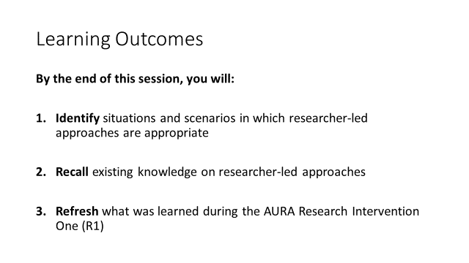
(2 mins)

Facilitation: The facilitator can introduce the learning outcomes of session 4 and address possible questions learners might have before introducing the experiential activity

Content: Through an activity we will now identify situations and scenarios in which researcher-led approaches are appropriate. The activity of this session will enable you to:
- Identify situations and scenarios in which researcher-led approaches are appropriate
- Recall existing knowledge on researcher-led approaches
- Refresh what was learned during the AURA Research Intervention One (R1)

Formative Assessment: It is recommended to address possible questions from learners before proceeding to the group activity.

Slide 3

(2 mins)

Facilitation: Introduce the group activity and organise learners into groups of maximum 5 members. Explain to them that they are required to write a scenario of maximum 250 words, looking at the examples provided that have been taken from the diagnostic exercise and that were also shared during the pre-online phase of R2. In each group, learners will have to assign roles and make sure to have a rapporteur and a presenter.

Based on previous needs’ assessment, the facilitator might need to reiterate the distinctions between researcher-led and citizen-led approaches to research before moving to the actual activity.

Even though this activity may seem to duplicate an elective activity assigned during the pre-online phase of R2, it is important to clarify that here learners are asked to write a clear scenario where researcher-led approaches to research are more appropriate because it was evident in the online discussion that this outcome needed additional support and practice in order to be achieved. In addition, while in the online phase, learners were asked to write a scenario individually, whereas now the learning process is reinforced and supported through peer learning.

Finally, the facilitator might want to reiterate that the online activity was elective and, therefore, the completion rate was low (if applicable).

Content: With your group members, you are asked to reflect on researcher-led approaches to research and what you know about them, and write a scenario of maximum 250 words that you think would be more appropriate for this type of approaches.

You need to make sure you assign clear roles within your group so that everyone is accountable of their own task. It is important to have a rapporteur and a presenter among the roles you assigned.

You are given 40 minutes to write the scenario and 5 minutes to present it to the rest of group.
Formative Assessment: In the structured group work, learners are required to support one another; this approach enables learners to learn from their fellow peers who would explain concepts and course materials without having any implied authority that might prevent some from feeling comfortable in asking for clarification or additional help. In addition, peer learning methods enable to reinforce the knowledge of those supporting their peers by prompting them to elaborate further and make their knowledge explicit.

Slide 4

(5 mins)

Facilitation: The facilitator might take into consideration the examples suggested to the questions on the slide during facilitation. However, they should only be considered prompts for consideration and not exhaustive or the only answers.
- In which domain of knowledge (disciplines) could researcher-led methodologies be of use?
  - [Prompt: theoretical physics - in any of the basic sciences that have very little consideration of outcome/impact (anything applied) of research (applied research) then these types of this researchers may struggle as this has nothing to do with people – atom for instance]. It might be useful to use a scenario that is borderline but is still researcher-led e.g. Finance – If you look at the volatility of financial indicators in the phenomenon. With regards the atom (is the phenomenon) in the extreme scenario
- What kind of phenomena can be studied through researcher-led research?
  - [Prompt: With regards to the atom, an example of an extreme scenario. Finance: the volatility of financial indicators in the phenomenon, a less extreme scenario]
- What research purposes might lead to researcher-led research designs?
  - [Prompt: Research purpose – informing academic debate, and the whole idea of knowledge for knowledge sake]
- What kind of research questions and outcomes could be addressed through researcher-led research methodologies?
  - [Prompt: In an extreme scenario, magnetism and electrons (research questions that are very technical or simply looking at how something in the physical domain behaviours, something that has implications or applications on human beings without someone else doing something with it). In the less extreme scenario of finance, looking at the volatility of financial indicators, how does a change in indicator 1 affect indicator 2, which would lead to a purely mathematical/statistical analysis i.e. researcher led. Could have implications for analysts and investors, they could lead the research and frame research questions so then this would turn it into citizen-led]
Before starting the activity, the facilitator should make sure that the prompting questions (and terms used in the questions) are clear, and address related questions with the support of the other learners rather than just answering himself/herself.

Content: While writing a scenario, in groups reflect on the questions in the slide and through discussion, come up with (and write down) one scenario where researcher-led approaches would be appropriate:
- In which domain of knowledge (disciplines) could researcher-led methodologies be of use?
- What kind of phenomena can be studied through researcher-led research?
- What research purposes might lead to researcher-led research designs?
- What kind of research questions and outcomes could be addressed through researcher-led research methodologies?

Formative Assessment: During the group activity, the facilitator should go around, observe the groups’ dynamics and listen to the discussion. If needed, it is important that the facilitator provides constructive feedback to group members or pauses the activity to address potential areas of confusion that might need to be clarified with the entire group. Observation can also provide the facilitator with interesting insight of learners’ weaknesses and strengths that might be taken into consideration for the next activities or days of the course.

In the structured group work, learners are required to support one another; this approach enables learners to learn from their fellow peers who would explain concepts and course materials without having any implied authority that might prevent some from feeling comfortable in asking for clarification or additional help. In addition, peer learning methods reinforce the knowledge of those supporting their peers by prompting them to elaborate further and make their knowledge explicit.

Slide 5

(5 mins)

Facilitation: This slide has to be completed by the facilitator depending on the results from the online phase.

If possible, it is good practice to connect face-to-face activities with online activities or with opinions shared by learners during the online session to highlight that the phases are interconnected and show that their insights and efforts to actively engage with elective activities online was appreciated and taken into consideration by integrating it into the design of the course activities.

Content: During the pre-online phase, some of you discussed with your peers different scenarios and examples for when researcher-led approaches are likely to be more appropriate; in those conversations, some questions have been raised, such as those on the slide OR some of the scenarios on the slide that have been submitted during the pre-online phase.

Formative Assessment: The work submitted during the online phase can be used as data during face-to-face activities as it is suggested in this specific case. This approach makes students feel appreciated and that their voices in the online environment have been heard. It also provides a chance to reinforce and clarify the knowledge acquired by providing ongoing feedback that is relevant and constructive.

Slide 6
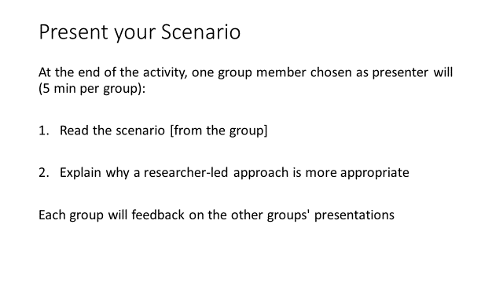

(2 mins: to present guidelines)
(40 mins - 5 mins for each group presentation, which could result in 40 mins if there are 8 groups)

Facilitation: The feedback from the other groups could be shared on post-it notes and read later on – if time doesn't allow to share it out loud – and considered during the final reflection)

Content: At the end of the activity, one group member chosen as presenter has 5 minutes to:
- Read the scenario (from the group)
- Explain why a researcher-led approach is more appropriate
- Your group will feedback on the other groups' presentations (the feedback could be shared on post-it notes and read later on – if time doesn't allow to share it out loud – and considered during the final reflection)
I (as the facilitator) might also join the discussion and provide feedback if needed.

Formative Assessment: Group discussions and shared learning with wider audience during which learners will give and receive constructive peer feedback.

Slide 7

(2 mins: to present guidelines)
(40 mins for alternative group activity)

Facilitation: As an alternative to the initial guidelines of the group activity, the facilitator could use the scenario(s) designed by learners during the pre-online phase and randomly assign them to groups to critique them. However, if the online phase had a low participation rate with limited submission of scenarios, the facilitator could choose/come up with scenarios.

This latest approach aims to model productive inquiry techniques (Dewey), and also to enable groups to discuss each other’s scenarios, giving a stronger link to the pre-online and the significance of engaging online.

Content: On the slide you can see an example of a scenario that I wrote as example for your activity OR a scenario that was submitted by one of your peers. I would like you to critique it within your group taking into consideration the reflective questions on slide 4.

Formative Assessment: During the group activity, the facilitator should go around, observe the groups’ dynamics and listen to the discussion. If needed, it is important that the facilitator provides constructive feedback to group members or pauses the activity to address potential areas of confusion that might need to be clarified with the entire group. Observation can also provide the facilitator with interesting insight of learners’ weaknesses and strengths that might be taken into consideration for the next activities or days of the course.

In the structured group work, learners are required to support one another; this approach enables learners to learn from their fellow peers who will explain concepts and course materials without having any implied authority that might prevent some from feeling comfortable in asking for clarification or additional help. In addition, peer learning methods enable to reinforce the knowledge of those supporting their peers by prompting them to elaborate further and make their knowledge explicit.
Slide 8
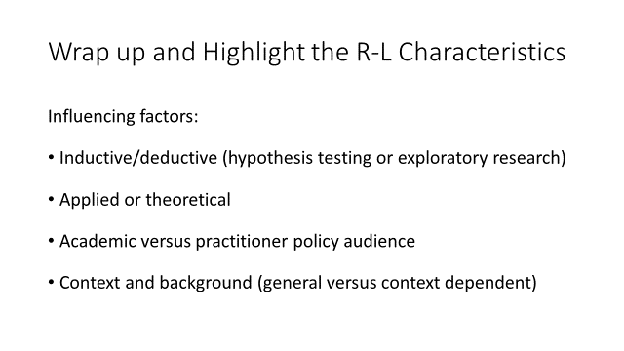
(5 mins)

Facilitation: After the group activity and the group presentation of their scenarios, the facilitator is recommended to wrap up by mentioning the highlights of the scenarios written by the learners, and by taking the influencing factors on the slide into account. It is important to clarify that all the factors mentioned on the slide are discipline dependent.

Content: (After the group activity and the group presentation of the scenarios written in groups) I would like to mention a few elements that were highlighted during your presentations.
It is important to clarify that all the influencing factors mentioned on the slide are discipline dependent:
- Inductive/deductive (hypothesis testing or exploratory research)
- Applied or theoretical
- Academic versus practitioner policy audience
- Context and background (general versus context dependent)

Formative Assessment: Constructive feedback shared by the facilitator on the groups’ presentation can be implemented by group which would then revise and finalise their scenario for researcher-led approaches to research.

Slide 9

