Research Course 1/Face-to-Face /Day 2/Session 12 (R1_F2F-D2-S12)
Title: Wrap up and reflection
Session Description:
(Overall time: 30 mins) This session enables learners to clarify their learning and reflect on how they could relate the new knowledge acquired during the course to their research practice. Learners will be thus able to embed the learning experience and consider the application of these approaches. This session should also provide the facilitator with the opportunity to gather feedback on how the course could be improved, further contextualised and tailored to the learners’ needs.

Learning Outcomes:

- Clarify your learning through reflection
- Apply learning to your research and teaching practice
Recommended Modality:
- Face-to-face
Learning Activities:
- (15 mins) A brainstorming activity that can be initially done either individually or in pairs, and that will enable learners to reflect on the key learning points suggested by the facilitator before engaging with the reflective journal task. After the initial reflection, learners are asked to briefly share their initial thoughts with the wider group. (LOs 1-2)
- (60 mins) A final assignment that requires learners to write a reflective journal expanding on one, or two, of the areas suggested by the facilitator, in nor more than 200-300 words. The reflective journal can be completed at the end of the day, and will be shared at the beginning of the following day to enable to implement suggestions, when possible, and address possible areas of confusion or interest for learners. (LO 1-3)
Formative Assessment:
- Questioning
- Peer feedback
Learning Resources:
- [R1-P11-S12] Power Point Presentation Session 12: Wrap up and Reflection. This presentation outlines the learning outcomes of the session, provides prompting questions to stimulate learners’ reflection individually or in pairs, and provides the guidelines for the reflective journal task.
Course Materials:
- Projector
- Computer

Presentation Slides
Slide 1

Points in bold are facilitation instruction - for example, they might indicate how to run a group discussion or brainstorming session.

Points in italic indicate things you should tell the audience. You can express them in your own words.

Underlined points refer to formative assessment techniques and indicate what you can learn from learner responses (although it is impossible to be comprehensive about all of the insights).

Slide 2

(1 mins)

Facilitation: Introduce the session by clarifying its learning outcomes.

Content: You are invited to reflect on how you could relate this new knowledge acquired to your research practice. This will help you embed the learning experience but also enable you to consider the application of these approaches. This also provides an opportunity to gather feedback on how this intervention could be improved, adapted and contextualised.

Formative Assessment: Setting clear expectations and outcomes at the beginning of the session is important to address possible questions at the very beginning of the session and avoid additional confusion during the activity.

Slide 3

(0 mins)

Facilitation: Show the slide and introduce the reflective activity.

Content: You are invited to reflect on what you have learned thus far. Reflection is a critical skill that will enable you to clarify any misunderstandings and apply what you have learned.

Formative Assessment: N/A

Slide 4
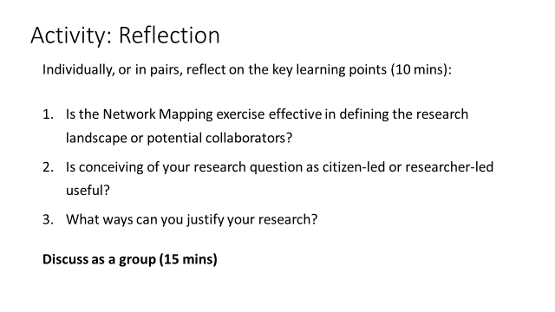

(Slide: 1 min)
(Activity: 25 mins)

Facilitation: Introduce the first of two activities, which would enable learners to start reflecting on how what they learned throughout the day relate to their research practice and how it might change their approaches to it. Learners should initially reflect either individually or in pairs on the key learning points, referring to the prompting questions on the slide. Then have learners share their thoughts with the wider group. This will help them to start reflecting on their research practice before engaging with the reflective journal task.

Content: As a whole group, reflect on the key learning points (15 min):
- Is the Network Mapping exercise effective in defining the research landscape or potential collaborators?
- Is conceiving of your research question as citizen-led or researcher-led useful?
- What ways can you justify your research?

Formative Assessment: The facilitator should make sure that the guidelines and prompting questions for the activity are clear, and address questions or confusion if needed.

Slide 5

(5 mins)

Facilitation: Introduce the reflective journal task that learners are asked to complete at the end of the day. Remind them that their journal will be shared at the beginning of the following day.

Content: Finally, for your learning journal pick one (or two) of the following areas to focus on:
- The networking mapping exercise
- Crafting research questions
- Justifying your research question
- Learning modalities: what approaches & how can you incorporate into your practice
Remember to include your reflections (200-300 words)

Formative Assessment: The facilitator should make sure that the guidelines for the activity are clear, and address questions or confusion if needed.

Slide 6

