Research Course 1/Face-to-Face /Day 2/Session 9 (R1_F2F-D2-S9)
Title: The Characteristics of a good research question
Session Description:
(Overall time: 90 mins) The purpose of this session is to appreciate how the distinctions between a ‘wicked’ and ‘tame’ problem can be applied to different research contexts. Learners will begin to comprehend the characteristics of a good research question and apply these criteria to their research question(s).

Learning Outcomes:
- Identify a ‘wicked’ and ‘tame’ research question based on learners’ experience that concerns other people or living systems
- Describe the characteristics of a good research question
- Apply these criteria to your research questions
Recommended Modality:
- Face-to-face
Learning Activities:
- (20 mins) A reflective activity that enables learners to refresh and share their knowledge on the distinctions on tame and wicked problems; learners will prepare a 5 minute presentation and share it with the wider group (LOs 1; 3)
- (3 mins) Quick group discussion to assess learners’ knowledge on the characteristics of a good research question and their connection with wicked and tame problems before moving to the activity covering this topic in mode depth (LOs 2-3)
- (10 mins) An exercise that requires learners to apply and connect what experienced and learned during the previous activities on the characteristics that make a good research questions as well as on wicked and tame problems. Learners will be asked to identify which questions, among the examples provided, reflect wicked or tame problems (LOs 1-3)
- (35 mins) An activity structured in two parts that enables participants to write their own tame and wicked research questions and thus connect the new concepts learned to their own field of research and their own questions (LOs 1; 3)
Formative Assessment:
- Questioning
- Peer feedback
- Needs’ assessment
Learning Resources:
- [R1-P08-S9] Power Point Presentation Session 9: 'Wicked' and 'tame' problems. This presentation outlines the learning outcomes of the session on wicked and tame problems, and provides guidance to prompt learners’ reflection on the relation between wicked and tame problems and good research questions.
Course Material:
- Computer
- Projector
- Paper and pens
Presentation Slides
Slide 1

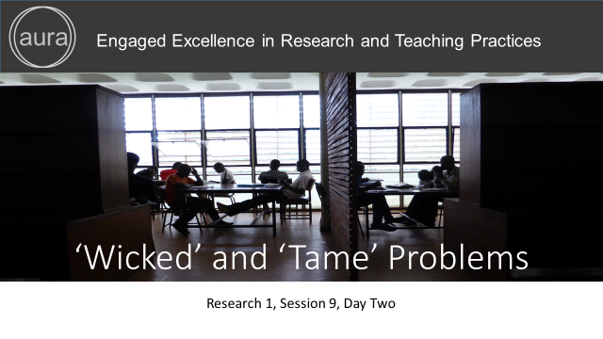

Points in bold are facilitation instruction - for example, they might indicate how to run a group discussion or brainstorming session.

Points in italic indicate things you should tell the audience. You can express them in your own words.

Underlined points refer to formative assessment techniques and indicate what you can learn from learner responses (although it is impossible to be comprehensive about all of the insights).

Slide 2

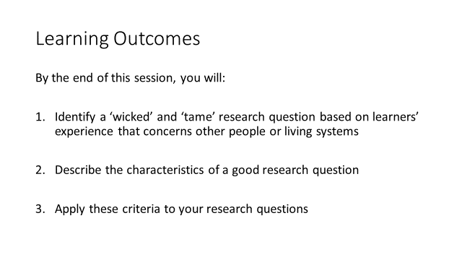

(2 mins)
Facilitation: Introduce the session and its learning outcomes
Content: In this session you will come to appreciate and identify how the distinctions between a ‘wicked’ and ‘tame’ problem can be applied to different research contexts. You will begin to comprehend the characteristics of a good research question and apply these criteria to your research question(s).
This particular session is fundamental in that many researchers may have only been exposed to ‘tame’ problems, where there are a limited number of perceived variable, for example three or four dependent variables, or where an experiment can be designed to minimise the number of variable so that the relationship between distinct variables can be explored.
This can be extremely effective but can also, for certain kinds of complex problems, lead to incorrect conclusions or conclusions that ignore a vital factor. Again the classic model of research tends to emphasise approaches and techniques to solve tame problems. The notion of ‘wicked’ problems is also connected with the concept systems thinking or systemic thinking where problems are approached holistically (i.e. as a whole).
Formative Assessment: N/A

Slide 3

(5 mins)

Facilitation: It is recommended that the facilitator assesses the level of understanding amongst the learners by asking leading questions to determine their comprehension of the distinction between open and closed problems. E.g. Ask individuals to comment on the characteristics of each problem and compare the differences. During this exercise they should relate their responses back to their experiences and identify a research question that it would fall under these types of conceptions.

If any learners is unclear with the concept of open and closed problems, the facilitator might want to want to quickly recap their meaning by showing the link to unstructured and structured questions as some learners may be more familiar with this distinction. They share the same characteristics as a tame (i.e. structured) and wicked (i.e. unstructured) problem.

Content: (for recap after the assessment of the basic concepts that will be analysed during this session): open problem (similar to wicked problem) refers to a problem whose solution is not known, it is an open question (you do not know what responses might be). ‘Wicked problems’ are problems that are difficult to define.
Formative Assessment: This quick needs assessment activity can highlight areas that need to be reviewed and give the facilitator a sense of the level of engagement of learners with the course materials shared during the online phase. This is a helpful assessment to make sure that the basic concepts are clear so that learners can actively engage with the activities planned for the day.

Slide 4

(5 mins)

Facilitation: (Same as slide 3) It is recommended that the facilitator assesses the level of understanding amongst the learners by asking leading questions to determine their comprehension of the distinction between open and closed problems. E.g. Ask individuals to comment on the characteristics of each problem and compare the differences. During this exercise they should relate their responses back to their experiences and identify a research question that it would fall under these types of conceptions.

If any learners is unclear with the concept of open and closed problems, the facilitator might want to want to quickly recap their meaning by showing the link to unstructured and structured questions as some learners may be more familiar with this distinction. They share the same characteristics as a tame (i.e. structured) and wicked (i.e. unstructured) problem.

Content: (for recap after the assessment of the basic concepts that will be analysed during this session): closed problems (similar to tame problems) refers to ended problems and that only have one solution to one answer (you do know what the responses are, it is either one or the other). ‘Open problems’ are problems that have not yet been solved, no ‘obvious’ solution is known. Tame problems – a gap that can be clearly defined or written down. Closed ended problems – only one solution leading to one answer, yes/no

Formative Assessment: This quick needs assessment activity can highlight areas that need to be reviewed and give the facilitator a sense of the level of the engagement of learners with the course materials shared during the online phase. This is a helpful assessment to make sure that the basic concepts are clear so that learners can actively engage with the activities planned for the day.

Slide 5

Source: http://www.odi.org/comment/8801-wicked-problems-development-aid-complexity-ramalingam

(Slide 5-6: total 20 mins)

Facilitation: Check if learners have read the blog post by Ben Ramalingam assigned as compulsory activity during the online phase. Ask learners to reflect on the table (which is presented in the blog post as well as on slide 5) that show the differences between wicked and tame problems. Learners can reflect on the table with the support of the questions on the next slide (Slide 6), prepare a 5 minute presentation of their views, which will then be asked to share with the wider group.

Content: In his blog post, Ramalingam introduces the distinctions between ‘wicked’ and ‘tame’ and how they have evolved in relationship to ‘closed’ and ‘open’ problems (as well as open and closed questions) and how this can apply to a range of research contexts (e.g. health, climate change, software development).

Read the blog post by Ben Ramalingam shared on the online platform as optional resource (or distributed as handout if applicable). Reflect on the table showing the differences between wicked and tame problems with the support of the questions that are listed on the next slide.

Identify research questions that might fall into these two categories

Prepare a five minute presentation of your views to share with the wider group

Formative Assessment: N/A

Slide 6

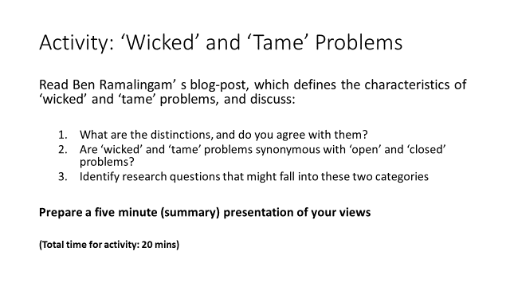
(Slide 5-6: total 20 mins)
Facilitation: (See slide 5) Ask learners to reflect on the table (which is presented in the blog post as well as on slide 5) that shows the differences between wicked and tame problems. Learners can reflect on the table with the support of the questions on this slide, prepare a 5 minute presentation of their views, which will then be asked to share with the wider group.

While individuals share their reflections with the wider group, the facilitator may connect the main points highlighted by learners to the topic and its connections to the characteristics that make a good research questions, referring to the main fields of expertise of the learners so that they can better related to the examples provided.

After the presentations, the facilitator will give a short summary of the highlights linking to the next session that focuses on the main characteristics of a good research question.

Content:
While reflecting on the distinctions between tame and wicked problems presented in the table in the blog post, consider the questions below (that are also on slide 6):

- What are the distinctions, and do you agree with them?
- Are ‘wicked’ and ‘tame’ problems synonymous with ‘open’ and ‘closed’ problems?
- Identify research questions that might fall into these two categories

Prepare a five minute presentation of your views to share with the wider group

Formative Assessment: Peer feedback during the presentation with the wider group. Constructive feedback provided by the facilitator and peers will enable learners to clarify possible areas of confusion as well as reinforce their understanding.

Slide 7
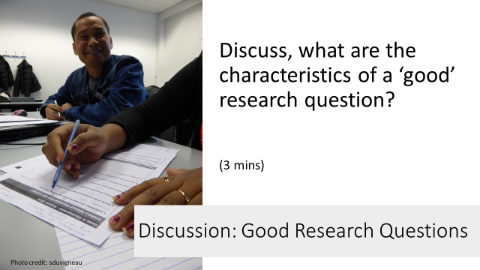
(Summary: 2 mins)
(Quick group discussion: 3 mins)

Facilitation:
Make the link between this and the previous activity explicit by providing a quick summary on the main highlights shared by learners during their 5 minute presentation and linking them to the characteristics that make a good research question.

Before showing the characteristics of a good research questions presented in the next slide, ask learners to discuss with the whole group the characteristics that make good research questions by drawing on their models or definitions of a good research question, in particular in the health context

Content:
Drawing on your models or definitions of a good research question, in particular in the health context highlighting PICO (Population, Intervention, Community, Outcome) and SMART (Specific, Measurable, Achievable, Realistic, Timebound), we questioned whether these conceptions of a good research question were appropriate for a wicked problem or research question. Hence, throwing doubt on the mechanistic interpretation of a good research question (i.e. what is meant by a ‘good’ research question?).

We also highlighted how in the past donors may have focused on tame research questions that may address the symptoms rather than causes of a problem or may not allow enough time to explore a question or phenomena and understand the root causes of a problem. However, we also discussed how a wicked problem may be broken down to become tame questions. But, trying to break down a complex wicked problem into its tame parts may simplify the problem and how tame factors relate to each other as a whole – thereby losing the ‘big picture’. This reflects a shift in thinking that is taking place amongst academics, researchers and donors, which this is a critical shift should be taken on board by you

Formative Assessment: The suggested quick group feedback on the characteristics that make a good research question is a quick needs’ assessment technique to both highlight potential areas that need to be reviewed or that need clarification before moving to the next activity and elicit learners’ pre-knowledge on the topic that will then be covered. The feedback provided by learners through their answers could potentially be considered by the facilitator to tailor and scaffold the next activities to the needs assessed.

Slide 8
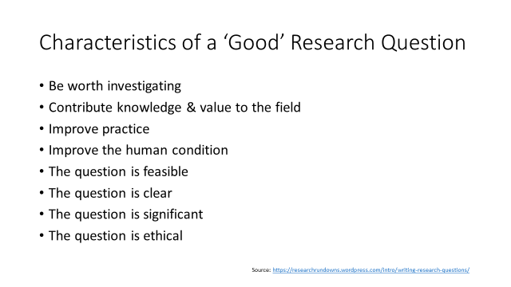
(5 mins)
Facilitation: The facilitator might provide a quick overview of some of the most important qualities that make good research questions, comparing them to what the learners have mentioned during the quick group activity. It is important that the facilitator elicits further reflection and connections between these characteristics and what learners mentioned through reflective questions.

Content: We will now look at possible qualities of a good research question and compare them to what the groups have mentioned.
Formative Assessment: The facilitator would provide feedback while helping learners making connections with their previous knowledge on the topic and the characteristics suggested by the facilitator on this slide.

Slide 9
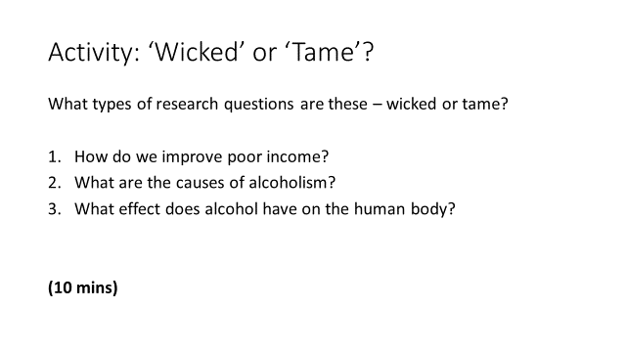
(10 mins)
Facilitation: Finally, to apply what learned and experienced through the two activities, learners will be asked to identify which research questions reflect wicked and tame problems among the examples presented on slide 9.
- How do we improve poor income? Answer: Wicked research question
- What are the causes of alcoholism? Answer: Wicked research question
- What effects has alcohol on the human body? Answer: Tame research question

After eliciting learners’ answer, the facilitator might provide a quick reflection and highlight that comparing the two examples of wicked and tame questions related to alcohol, it is clear that if you define the variables you have a tame research questions.

The facilitator might consider suggesting additional examples of wicked questions related to the research field of learners. A few wicked questions are listed below as examples suggested by the learners and related to health research:

- What are the health implications of Malaria in pregnancy in the coastal region?
- What is the economic impact of malaria in Tanzania?
- Understanding malaria drug resistance and magnitude of counterfeit malaria on malaria control.

The facilitator can also reiterate that with tame research questions, it is very clear how to resolve that questions and that there will be one answer to the question.
Question 2 is a 'wicked' problem and would be approached holistically from a systemic perspective. Here the emphasis would be on exploration of the phenomena under investigation in addition to understanding that there is no predicted outcome of the research, no hypothesis to be proved or disproved. For example if such a study was focused on a particular community one would probably want to understand the people, the social context, the environment and start to identify common features and how factors may be interconnected. This helps to understand the, often complex and sometimes unexpected range and interplay of intervening 'variables'. This may lead to exploring systematically the relationship between factors. Whereas in question 3 a prediction can be made and an experiment can be envisaged and conducted to determine the impact of alcohol on the human body.

Content: I will read out a few examples of research questions and I would like you to try to identify them as wicked and tame research questions. Examples of wicked and tame research questions are below (and on slide 9):
- How do we improve poor income?
- What are the causes of alcoholism?
- What effect does alcohol have on the human body?
Comparing the two examples of wicked and tame questions related to alcohol (Q. 2 & 3 above), it is clear that if you define the variables you have a tame research questions

(After activity) I would like to reiterate that with tame research questions, it is very clear how to resolve that questions and that there will be one answer to the question.

Formative Assessment: Constructive feedback should be provided based on the reflections and answers provided by learners that might highlight the need of further clarification.

Slide 10
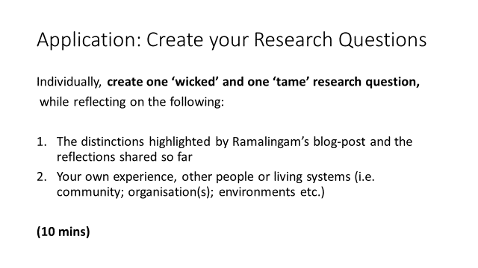
(10 mins)

Facilitation:
The facilitator should make sure that the distinctions between tame and wicked problems are clear and then move to this activity where learners are required to write their own research questions that reflect a wicked or tame problem.

Ask learners to create a ‘wicked’ and ‘tame’ research question while reflecting individually on the distinctions between the two problems highlighted by Ramalingam in his blog post and on their experience that concerns other people or living systems (a community, people in an organisation, environments etc.).

Learners will draw on previous knowledge from their own personal experience, research interests and areas where they would like to do research as a community of practice as well as on what learned during the previous activities and sessions. This will help learners see the relevance and help them foster motivation for working with a wider stakeholder to identify a common area.

Content: Now, you will write your own ‘wicked’ and ‘tame’ research question while reflecting individually on the distinctions between wicked and tame identified in Ramalingam’ s blog post and on your experience that concerns other people or living systems (a community, people in an organisation, environments etc.).

You will have 10 minutes to individually reflect and craft your two research questions.

Formative Assessment: N/A

Slide 11
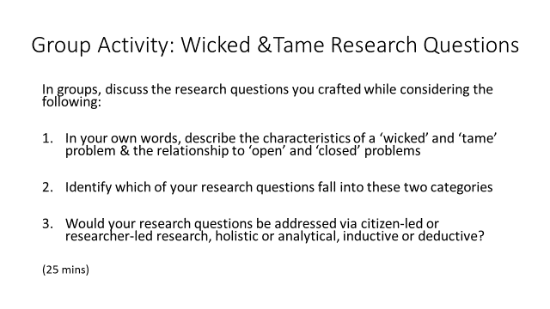
(25 mins)

Facilitation: After 10 minutes of individual reflection and work on their own research questions, ask learners to come together as a group of maximum 4 members, and to share and discuss their research questions with their peers.

Clarify to learners that they have to explain the research questions they crafted to their peers, addressing in their discussion the points highlighted on slides 11 & 12. The facilitator might explain that the group discussion on individual research questions will help them share their different perspectives and background and tackle research with a multidisciplinary approach thus experiencing and applying mixed methodologies.

It is recommended to clarify that learners should try their best to write at least a potential research question (either during the individual activity or with the support of their peers in this activity) as they will be asked to work on their questions during the next session.

If the facilitator notices that learners struggle to apply what learned to the writing of their own research questions, an alternative option could be to model an approach as a group where learners create a list of research questions and then grouped themselves under the question that responded to their areas of interest. Learners may also choose to bring their own research question – this is particularly helpful for those learners who are working on a current research problem (e.g. young scholars).

Content: Now, I would like you to come together as a group (of four) and reflect on the distinctions between the two types of research questions you all wrote. Each group member should share one or both research questions (if you could write one tame and one wicked question) with the wider group, discuss them and share your thoughts with the rest of the group while looking at the points highlighted on the slide:

- In your own words, describe the characteristics of a ‘wicked’ and ‘tame’ problem & the relationship to ‘open’ and ‘closed’ problems
- Identify which of your research questions fall into these two categories
- Would your research questions be addressed via citizen-led or researcher-led research, holistic or analytical, inductive or deductive?

I would like to clarify that the group discussion on individual research questions will help you to share your different perspectives and background and tackle research with a multidisciplinary approach thus experiencing and applying mixed methodologies.

It is also important that you write at least one question as you will be asked to work on it/them further in the next activities. If you didn’t manage to do so during the individual activity, please use this group activity as a chance to write at least one research question (either tame or wicked question) with the support of your peers.
For instance, as a group you can create a list of research questions and then grouped team members under the question that responded to their areas of interest. In your group or individually you may also choose to bring your own research question – this is particularly helpful for those of you who are working on a current research problem (e.g. young scholars).

Formative Assessment: This group activity would support learners in their learning process by providing peer feedback and support to make sure that all learners can write at least one research question or enhance what they wrote during the individual activity. While learners work in groups, the facilitator can go around groups and listen to their discussion to make sure to address potential areas of confusion providing formative feedback.
Slide 12

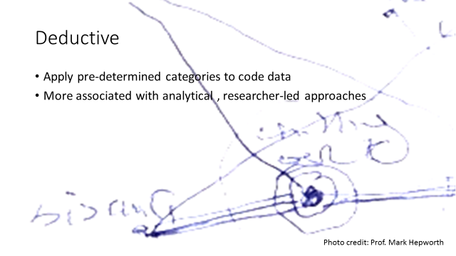

(2 mins)

Facilitation: If according to the facilitator, learners need additional clarification on the terms deductive and inductive, the slide 12 & 13 are provided as additional stimulus material.

Content: Deductive, analytical, and researcher-led are more likely to be associated with each other

Formative Assessment: The facilitator should assess the needs and knowledge of learners and address potential areas of confusion or decide to spend more time on these topics before moving to the next session.

Slide 13

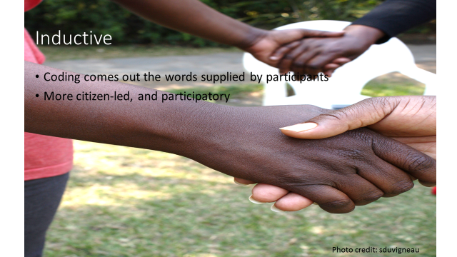

(2 mins)
Facilitation: If according to the facilitator, learners need additional clarification on the terms deductive and inductive, the slide 12 & 13 are provided as additional stimulus material.

Content: Inductive - Applying pre-determined categories to code date (The coding would come out of the words that people are saying). Inductive is more citizen-led and participatory in nature.

Formative Assessment: The facilitator should assess the needs and knowledge of learners and address potential areas of confusion or decide to spend more time on these topics before moving to the next session.

Slide 14

