Research Course 1/Face-to-Face /Day 1/Session 7 (R1_F2F-D1-S7)
Title: Universal Session – Reflective Practice
Session Description:
(Overall time: 60 mins) The purpose of this session is to introduce learners to the importance of reflective practices and to the reflective journal task, which is a compulsory element of the course. All learners are expected to create a reflective journal entry and share this at the end of each day. This session will introduce the learner to the ‘ORID Focused Conversation Method’ (Spencer, 1998; Hogan, 2003), and model how to create a reflective journal using prompt questions and lead-in phrases.
Learning Outcomes:
- Explain why a reflective practice is important as a lifelong learner
- Write a reflective journal entry using the focused conversation method
- Provide (and receive) feedback to your peers’ reflective journals
Recommended Modality:
- Face-to-face
Learning Activities:
- (15 mins) An ice-breaker activity that enables learners to consider the value of fostering a reflective practice. (LO 1)
- (15 mins) Learners are invited to create their reflective journal entry using leading phrases to guide their reflections. The leading phrases provide a useful structure for those that are less familiar with reflective practices as it encourages deep thinking, interpretations and conclusions as opposed to merely recording the facts. (LOs 1-2)
- (10 mins) An activity that enables learners to share their reflective journal entry with a peer to elicit their thoughts and feedback. This activity will enable learners to practice giving and receiving constructive feedback, which would be used to improve their journal; peer assessment and feedback is an extremely supportive strategy for learning new skills. (LO 3)
Formative Assessment
- Questioning
- Peer feedback
Learning Resources:
- [R1-P06-S7] Power Point Presentation on Reflective Practices. This presentation provides activities to introduce learners to reflective practices and to writing reflective journals, which is a compulsory task required in all the courses delivered by the programme. That is why the presentation is “universal” and requires to be tailored to different contexts and audience (e.g. educators or researchers).
Course Materials:
- Projector & Computer
Reference:
Hogan, C. (2003). A Toolkit of Techniques, Chapter 3, Kogan Page Publishers.
Spencer, L. J. (1998). Winning through Participation: Meeting the Challenge of Corporate Change, Kendall Hunt Paperback.
Presentation Slides
Slide 1

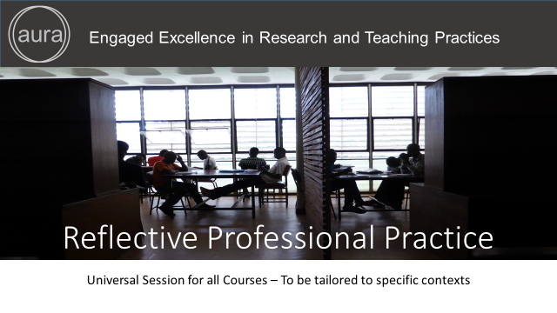

Points in this script are facilitation instruction - for example, they might indicate how to run a group discussion or brainstorming session.

Points in italic indicate things you should tell the audience. You can express them in your own words.

Underlined points refer to formative assessment techniques and indicate what you can learn from learner responses (although it is impossible to be comprehensive about all of the insights).

Slide 2

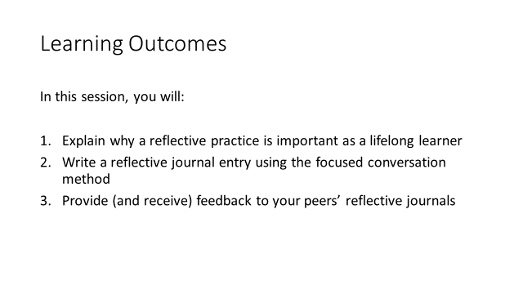
(1 min)

Facilitation: Show the slide and highlight the learning outcomes of the session.

Content: This session will introduce you to reflective practices. By the end of this session, you will have discovered why a reflective practice is an important professional development skill as well as practiced writing a reflective journal; you will also listen to your peers, and give – as well as receive – formative feedback to improve your journal.

Formative Assessment: Setting clear expectations and outcomes is important to address possible questions at the very beginning of the course or session and avoid confusion.

Slide 3

(6 mins)

Facilitation: Show the slide and ask the opening questions. Invite two or three individuals to share their thoughts.

Content: Before we learn the theory behind reflective practices, take a few minutes and reflect on the two questions shown here. Why do you think it is important to reflect and reach informed decisions about your professional practice or experiences? Finally, how should you record these reflections? The image to the right shows a page from the reflective journal of the educator who wrote this course. She prefers to write her reflections in a paper journal. Is this the only way you could record your insights? I will give you one minute’s thinking time now.

[One minute thinking time] Okay, let’s share some insights. Why is it important to reflect and reach decisions about your professional experiences? [Some of the reasons for reflecting on your professional practice is shown in the next slide so for now it is important to elicit responses that focus on: improving one’s professional practice; reaching decisions about what learning activities or plans worked and didn’t work, and why; helps record experiences for professional reviews; and monitors or tracks the reasons for changing approaches or learning curricula]. So, moving on to the second question - What format could a reflective journal take? [Reflective journals can be made in any format. They can be digital diaries in the form of a blog for instance. Or, they can be written in a journal or typed up and stored in a folder. Innovative technology-based approaches include: video and audio files. Some individuals also like to draw pictures and mind-maps].

Formative Assessment: These questions will tell you about individuals’ prior experience of reflective journals. A helpful question is to ask how many individuals already write reflective journals before moving on to the questions in the slide.

Additional Reading: Hogan, C (2003), “ORID Focused Conversation Method”. [Online] https://www.bridgew.edu/sites/default/files/relatedfiles/ORID-discussion-method-6.3.14.pdf. Accessed: 18 August, 2016
Slide 4
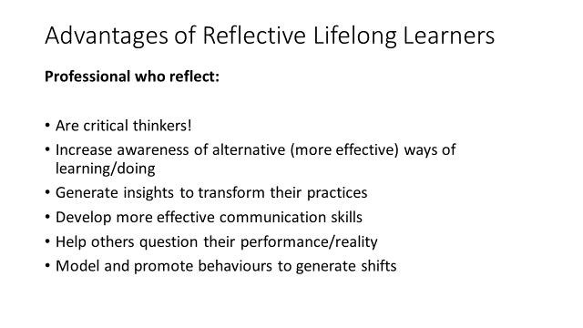

(2 min)

Facilitation: Show the slide and reinforce some of the advantages. It is recommended to tailor the content to the specific audience you are targeting (e.g. educator, students, professionals).

Content: Reflective practices are used by lifelong learners during their professional training, and through-out their career. They have several advantages: they help, for instance, in the process of reviewing practices and implement change; they enable individuals to identify what could be improved or delivered differently; they also support to reflect on ways of doing and provide feedback to peers in a way that will help groups or individuals reflect on and monitor their own performance. Increasingly, education is moving away from only supplying knowledge (i.e. Learning to know or supply-push education) to demand-pull education methods (i.e. Learning to be, critical thinking and sharing tacit knowledge). Therefore, a reflective practice can help individuals to focus on the application of knowledge and skills rather than the traditional modality of ‘building up repositories of knowledge’. A reflective practitioner is a critical thinker. They use structured approaches to analyse and interpret events (or experiences) in order to reach informed decisions about the best way to improve these experiences going forward.

Formative Assessment: N/A

Additional Reading: Brown, J. S. & Adler, R. P. (January/February 2008) “Minds on Fire, Open Education, the Long Tail, and Learning 2.0” EDUCAUSE Review, 43(1), pp. 16-32.

Slide 5
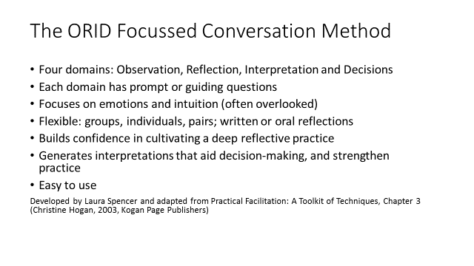
(2 min)

Facilitation: Show the slide and introduce the framework.

Content: We are going to use a flexible but structured framework to capture our reflections during the course. The framework is called ORID or the focussed conversation method. It was developed by Laura Spencer (Institute of Cultural Affairs) and then later adapted by Christine Hogan. This framework can be used to capture oral reflections in groups or it can be used to guide written reflections. This co-operative model of reflection is based on David Kolb’s experiential learning model, which we referred to earlier today. The framework is useful for de-briefing and reaching decisions with the support of your peers. The framework draws on four domains (similar to Kolb’s experiential learning cycle, which we’ll come onto later), and guides reflections, interpretations and decisions through the use of prompt or guiding questions. As a structured approach, it models and builds confidence in capturing insights (or reflections) as well as builds the capacity of the listener to support the reflector to enhance the quality of their reflections (and comprehend their perceptions). Significantly, the framework encourages individuals to express their emotions (or intuitions). This is an area that is often overlooked in decision-making processes, and if ignored could undermine the decision made. Ultimately, cultivating a reflective practice will help you to gain a broader and deeper understanding of your professional experiences, and in the process become more competent in critical thinking.

Formative Assessment: Before moving to the next slide, it is recommended to assess learners’ understanding by posing questions or elicit their thoughts. Based on that assessment, the facilitator might decide to provide formative feedback and/or clarify possible areas of confusion.

Additional Reading: Hogan, C (2003), “ORID Focused Conversation Method”. [Online] https://www.bridgew.edu/sites/default/files/relatedfiles/ORID-discussion-method-6.3.14.pdf. Accessed: 18 August, 2016.

Slide 6

(3 mins)

Facilitation: Show the slide and explain Kolb’s model. It is recommended to tailor the examples mentioned to clarify the model to the specific audience you are targeting (e.g. educator, students, professionals).

Content: As lifelong learners we should reflect on our educational/professional experiences at regular intervals, usually at the end of a session (or lecture) or at the end of a course/task. The types of questions that critical thinkers ask include: what could I have done better? How could I improve the session next time? Do I need to change anything? What knowledge, skills or attitudes do I need to develop in the learner that isn’t currently included in the curriculum? A useful model to help educators work through this reflective process is David Kolb's experiential learning cycle. Kolb argued there are four different stages of learning: concrete experience, reflective observation, abstract conceptualisation and active experimentation. Although the model is represented as a cycle the process can be entered any point. The only requirement is that in order to successfully reflect on, interpret and reach decisions about the learning process the learner must follow the cycle in sequence.

Let’s walk through the stages now to get a better understanding of Kolb’s model. When we have a concrete experience we are engaged in 'doing', this could be likened to participating in a debate or teaching students on a course. This is a concrete experience that we can observe and analyse.

When the experience has passed we have the opportunity to observe and reflect on this experience from a (metaphorical) distance. We may ask ourselves challenging or informative questions about the experience. During this process we may feel uncomfortable or highly elated (because things went well). All of these reflective observations (i.e. insights or observations) will inevitably lead us to interpretations (i.e. abstract conceptualisation) about how the experience could be altered. We may discuss these with our colleagues and glean further insights (or interpretations) about how the experience could be improved. Once, we feel confident about our interpretations we reach a conclusion about how to introduce effective changes. We will experiment and test our conclusions (these could be new strategies, skills or even behaviours). It is through the process of active experimentation that we learn what will work in the future when we encounter the concrete experience again.

The terminology Kolb uses is quite jargonistic so let’s simplify the language and look at the model again.
Formative Assessment: Before moving to the next slide, it is recommended to assess learners’ understanding by posing questions or elicit their thoughts. Based on that assessment, the facilitator might decide to provide formative feedback and/or clarify possible areas of confusion.

Additional Reading: Simply Psychology. “Kolb’s learning styles and experiential learning cycle” [Online] Available at: http://www.simplypsychology.org/learning-kolb.html. Accessed 24 August, 2016.

Slide 7
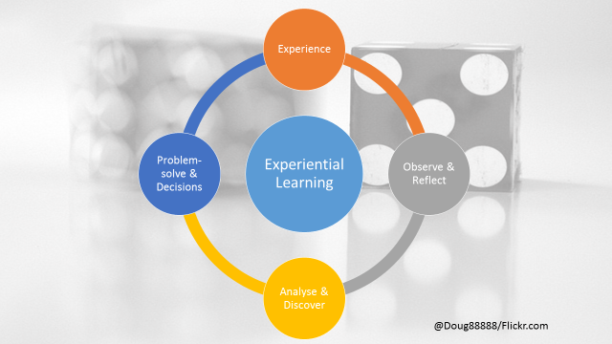
(1 min)

Facilitation: Show the slide and introduce another way of looking at Kolb’s experiential learning cycle. It is recommended to tailor the examples mentioned to clarify the model to the specific audience you are targeting (e.g. educator, students, professionals).

Content: Here is another way of looking at Kolb’s experiential learning cycle. This time we have simplified the language to: experience; observe & reflect; analyse & discover; and problem-solve and decisions. There are four stages to learning through experience and this includes: an experience, the space to observe and reflect on this experience (capturing all that surprised or made us feel uncomfortable during the event); and then we move into an analytical and problem-solving stage. The diagram suggests that this is a linear process but Kolb stressed that it shouldn’t be viewed this way. We may encounter a decision that makes us feel uncomfortable (i.e. changes to curricula for instance). In order to accept these changes we will need to analyse our concerns and reach decisions about how to proceed before we can implement the changes (i.e. encounter the new experience). So, we may enter the cycle at a specific point, and jump from decisions to reflections and back again (for instance). However, it is important that in order to process or comprehend the learning outcome(s), we go through the cycle of: reflecting, analysing and making decisions. Does anyone have any questions about the model before we move on? [If individuals are a little bemused or confused then try to allay their concerns by moving onto the next slide promptly]

Formative Assessment: Before moving to the next slide, it is recommended to assess learners’ understanding by posing questions or elicit their thoughts. Based on that assessment, the facilitator might decide to provide formative feedback and/or clarify possible areas of confusion.

Slide 8
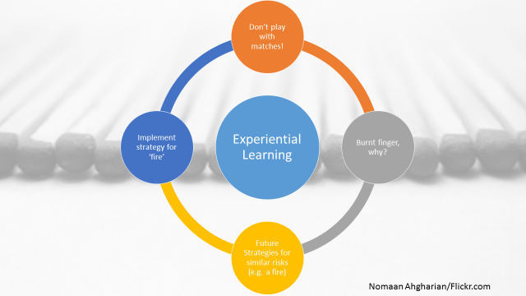
(10 mins)

Facilitation: Show the slide and invite one or two participants to share their insights by walking through the model. Invite the group to share their experiences with a learning peer. Walk around the room and support this process. Leave two minutes at the end for two or three individuals to share their experiences. It is recommended to tailor the examples mentioned to clarify the model to the specific audience you are targeting (e.g. educator, students, professionals).

Content: An excellent way to comprehend Kolb’s model is to apply the model to learning events encountered in our everyday lives. For example, when we were children we were told not to put our hand in the fire. Some of us may have reflected on this advice and decided to test it by placing our hand close to a flame (this is a concrete experience), the heat may have burnt our finger and as we nursed our charred 'ego' we might have reflected on our elder’s advice, or how the experience made us feel (Reflective observation).
We probably concluded that the advice was correct (Abstract conceptualisation) and planned in future to take heed of our elders' advice (Active experimentation). We may have concluded that it would be wise to be more cautious around fire in the future. If your elders told you that your nose would grow longer every time you lied then you may, after a period of reflection (and observation), conclude that some of their advice is valid and others less valide… and so the process goes on.

Does this feel familiar to you? What experiences from your childhood or adult lives could be described using Kolb’s experiential model? Spend a few minutes reflecting before sharing your experience with the person beside you (4 mins). Now let’s share some of those experiences in the group…

Formative Assessment: This activity will tell you whether individuals comprehend the learning cycle. It also gives you some insight into their ability to reflect, analyse and reach decisions, which may impact the way you review concepts in the later slides. The facilitator is recommended to monitor learners’ progress during the activity, provide constructive and immediate feedback to make sure possible confusion is addressed promptly before moving to the next session/activity.

Slide 9

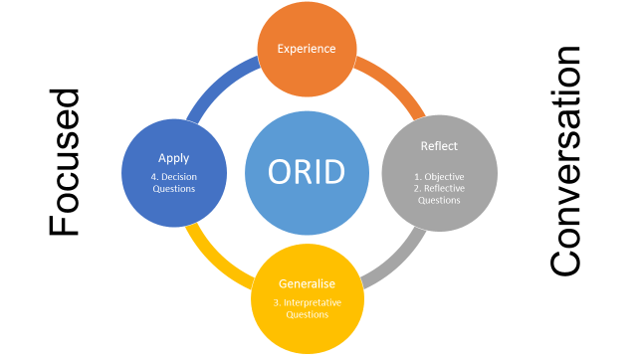

(2 min)

Facilitation: Show the slide and introduce the Focussed Conversation Model. It is recommended to tailor the examples mentioned to clarify the model to the specific audience you are targeting (e.g. educator, students, professionals).

The reflective practice is like assembling a landscape of knowledge and experiences in our mind. Making links to what is already known, enhancing these experiences through new knowledge will help us to be more effective in our work and personal experiences.
- There are several ways we can formalise the process of reflection. We can use frameworks (such as an assessment rubric) or probing questions to guide the process of reflection.
- In this training course, we will be using the learning journal guidance to perform self-assessments, also known as ORID. The guidance contains leading questions that will help you to capture what we have learnt and relate the learning to our job-related tasks.
- It is essential however, that we don't just record the facts (by remembering or understanding only shown in Bloom’s Taxonomy) but that we include our reflections on the importance on what has been learnt, and that we evaluate and create new meaning. As trainers, we are not looking for the best 'record' of key learning points. Actually, what we seek evidence of is the way our participants have been transformed by the learning. In other words, what decisions have they come to that will inform their job-related tasks.
- Other ways we can help the learner reflect is to ask their peers to provide an assessment.

Content: We’ve considered why it is important to cultivate a reflective practice, and looked in more detail at a model for capturing learning about concrete experiences. Now I will introduce you to Spencer and Hogan’s Focussed Conversation Model. It is based on Kolb’s learning cycle but uses less jargonistic terms to define the stages. These are: Experience, Reflect, Generalise and Apply. In each of these four domains (or stages) there are prompt questions, which have been labelled: Objective and Reflective Questions; Interpretative Questions and Decision Questions. Note: Objective questions draw on facts and observable data so you will be expected to capture evidence pertaining to the event (or experience). However, you will couple these facts with comments that are reflective in nature. You will use the guiding questions to capture your moods, feelings and intuition. Once this stage is complete you will be asked questions that consider the value, meaning or significance of the event before asking questions that guide your decisions and determine future resolutions.

Formative Assessment: Before moving to the next slide, it is recommended to assess learners’ understanding by posing questions or elicit their thoughts. Based on that assessment, the facilitator might decide to provide formative feedback and/or clarify possible areas of confusion.

Slide 10

(1 min)

Facilitation: Show the slide and explain the adapted process.

Content: Learning to become a reflective practitioner can be challenging and it’s a skill that can take time to master. Based on our former experiences (running this session) we have simplified the model even further to identify four questions that will help you build confidence and acquire the skill of reflective practices more efficiently. In a moment, you will be invited to prepare your first reflective journal for this course. In order to make this process relatively easy, we have identified four questions (from the ORID Framework) that will help you write your journal entry. These are shown on the slide and are taken from the four domains in Spencer and Hogan’s model (and drawn from Kolb’s experiential learning model).

The first two questions relate to the reflection domain and capture objective and reflective insights. The questions we will use to guide this process are: what ideas/people caught your attention, and why? Through-out the course we ask you to share your high/low points (in the Mood Monitor). This is intentional as it helps you frame your thoughts around an experience that has some value or significance (i.e. a high point or a low point). You may find it also helpful to ask this additional question when you are reflecting on your experience. Once you have objectively recorded facts and considered their significance (and how it made you feel), you will move onto questions that encourage conclusions and decisions.

Formative Assessment: Before moving to the next slide, it is recommended to assess learners’ understanding by posing questions or elicit their thoughts. Based on that assessment, the facilitator might decide to provide formative feedback and/or clarify possible areas of confusion.

Slide 11

(3 mins)

Facilitation: Show the slide and explain the activity.

Content: In the past we have found that individuals struggle to write their first reflective journal so we have devised these lead in phrases to help you respond to the prompt questions and write reflectively, interpretatively or decisively. For your first reflective journal entry, please use the phrases shown in this slide. These are:

- Today, I was struck by… (Objective reflection)
- This high/low point made me feel… (Reflective)
- I concluded… (Interpretive)
- I will do X…. In the future (Decision)

You will be given 15 minutes to complete your reflective journal entry and invited to share this reflection with the person beside you. Who should listen carefully and offer constructive feedback on how to improve your entry. Before you do this, let’s look at some examples.

Formative Assessment: N/A

Slide 12

(5 mins)

Facilitation: Show the slide and read out the quote slowly.

Content: [read the quote]. This is a reflection of one of the sessions covered today. Has the individual used the leading phrases? What do you think about the quality of their reflections, interpretations and decisions? [Note: although the individual has used the leading phrases they haven’t adequately analysed (or at least captured) insights and justified reasons for changing their practice going forward. It is very important that you think about the ‘why’ question when you write your journal. If you decide to change your materials it is important to state why are you doing this.

Formative Assessment: This question indicates whether people are able to justify their decisions etc. Spend time making sure that everyone understands why this is a weak example.

Slide 13

[This slide is a resource slide only. It can be used to show the leading phrases and highlight the lack of evidence in the responses].

Slide 14

(5 mins)

Facilitation: Show the slide and read out the quote slowly.

Content: [read the quote]. This is a slightly enhanced version of the same quote. As an educator I would regard this as a stronger reflective entry. Why do you think that is the case? [Here the writer has made an attempt to justify their reasons or insights. They have indicated the reasons for feeling uncomfortable (i.e poor student performance) and discussed how changes will be tested with students].

Formative Assessment: This question indicates whether people are able to justify their decisions etc. Spend time making sure that everyone understands why this is a stronger example.

Slide 15

[This slide is a resource slide only. It can be used to show the leading phrases and highlight the lack of evidence in the responses].

Slide 16

(15 mins)

Facilitation: Show the slide and explain the activity. Walk around the room and observe the learners. If some individuals look puzzled or are unable to start writing – offer them support or walk them through the process orally first.

Content: You now have 15 minutes to complete your reflective journal entry. Remember to use the leading phrases shown on the slide.

- Today, I was struck by… (Objective reflection)
- This high/low point made me feel… (Reflective)
- I concluded… (Interpretive)
- I will do X…. In the future (Decision)

Formative Assessment: Observe activity, this will tell you if individuals are experiencing problems. Look for confused or troubled faces first before moving onto randomly checking individuals’ entries.

Slide 17

(15 mins)

Facilitation: Show the slide and introduce the next activity.

Content: You have all made a great start. Now I’d like you to share your journal entry with the person beside you. This is a great way to build confidence as you only have to share your insights with one person. Some of you may feel more confident and able to share your insights with the group but this is advisable not compulsory. Spend 5 mins each listening and improving your peer’s reflective entry. Try to be constructive in your feedback, and definitely do not be overly critical. The type of questions or support that will help individuals improve their entry are those that tease out more information; unpack what is assumed and makes explicit the significance of the learning experience. When you are listening to your peer’s journal entry make a note of areas that could be improved.

Formative Assessment: Peer support and feedback is an extremely helpful way to reinforce ideas, and get individuals to practice giving meaningful feedback. Walk around the room and listen to this process. Are there questions individuals should be asking, or points they could have made?

Slide 18

(5 mins)

Facilitation: Show the slide and introduce the compulsory course activity.

Content: A compulsory output for all learners on this course is the production of one reflective journal. You will be expected to go home tonight and select one additional event or experience to analyse, interpret and reach a decision on. This journal entry will be assessed by the facilitator, who will also provide feedback on how you can make improvements going forward. This activity should take no longer than 30 minutes. The length of the journal entry is entirely up to you but please do not write less than 100 words. We will be communicating and sharing reflective journals on the morning of Day 2 so please be prepared to share and hand-in your reflective journal entry. Please use the leading phrases to guide your writing process.

Are there any questions about the course task? [Yes, you will be expected to give the facilitator a copy of your reflective journal entry. It should be longer than 100 words. Use the leading phrases to guide your reflections. It is a compulsory task and will be assessed by your facilitator. Reflective entries will be communicated and shared on ADD DAY].

Formative Assessment: N/A

Slide 19
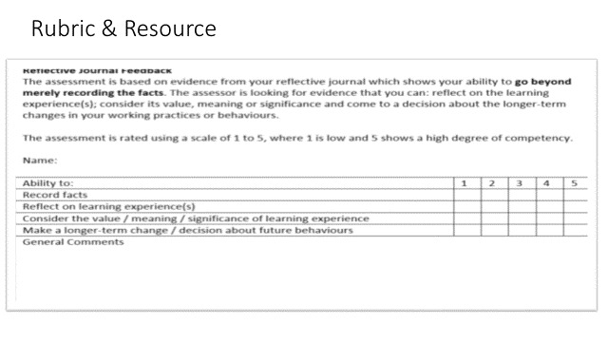
(5 mins)

Facilitation: Show the slide and introduce the assessment rubric. Circulate copies of the ORID Framework (in hard or soft copy).

Content: This is the rubric the facilitator will use to assess your reflective journal entry. You will notice you are given a score from 1-5 to indicate your competency level in writing reflectively (including capturing facts); interpretatively and decisively. These assessment will be returned to you within a two week timeframe [or provide a date if known].

Copies of the ORID Framework are also available to support this task.

Are there any questions about this task?

We have now come to the end of this session. We have covered a lot of ground so it is appropriate that we end the day reflecting on the significance of capturing our insights as they happen! Cultivating a regular reflective practice will also help you to think about how you will apply what you have learned today (and in the future). Please be prepared to come tomorrow with your reflective journal. We will be communicating and sharing them, as a group, at the beginning of the day.

Formative Assessment: Ensure that everyone is clear about the expectations for this task. You could ask individuals to feedback their confidence levels by using the coloured card (red = not sure, yellow = a bit confused but could proceed, and green = I’m clear). Ask individuals who have shown red or yellow cards to join you at the front of the room, and respond to their questions in the group. This is important, some individuals may have similar questions so you can eliminate duplication by responding to questions in a group. For those individuals who remain unsure, have a one to one conversation once the majority of the group is satisfied and can proceed with the activity.

Slide 20

