Teaching Course 3/Day 1/Session 3 (T3_D1-S3)
Title: Introduction to technology tools & the Pedagogical Wheel
Session Description:
(Overall time: 60 mins) The purpose of this session is to enable learners to refresh their technical knowledge of basic technology tools, and reinforce the concepts related to technology enhanced learning covered in the previous session, in order to make sure they can actively engage with the other sessions planned for the course. This session is highly recommended if the initial needs’ assessment analysis identified a lack of technical skills and the need of covering basic knowledge on the use of technology in education.
Learning Outcomes:
- Explain what basic technology resources are (e.g. podcasts)
- Illustrate the use of technology tools in relation to the type of skills and capabilities to be enhanced
Recommended Modality:
- Face-to-face
Learning Activities:
- (50 mins) A group activity that enables learners to refresh their knowledge of basic technology tools and their potentials in supporting the enhancement of learning. Each group is assigned of a specific section of the pedagogical wheel and has to research the tools they do not know about and design examples of activities that would develop the cognitive skills of that section (20 mins). Groups will then share with their peers to make sure the main tools and concepts are covered (30 mins) (LOs 1-2)
Formative Assessment
- Questioning
- Peer feedback
Learning Resources:
- [T3-P03-S3] Power Point Presentation Session 3: Introduction to technology tools for teaching and learning. This presentation provides guidelines for an activity during which learners can refresh or strengthen their knowledge of basic technology tools. They will be also introduced to the pedagogy wheel as a tool to help them reflect on how to choose tools for specific pedagogical purposes.
Course Materials:
- Projector
- Computer
- At least one laptop per group

Presentation Slides
Slide 1

Points in bold are facilitation instruction - for example, they might indicate how to run a group discussion or brainstorming session.

Points in italic indicate things you should tell the audience. You can express them in your own words.

Underlined points refer to formative assessment techniques and indicate what you can learn from learner responses (although it is impossible to be comprehensive about all of the insights).

Slide 2
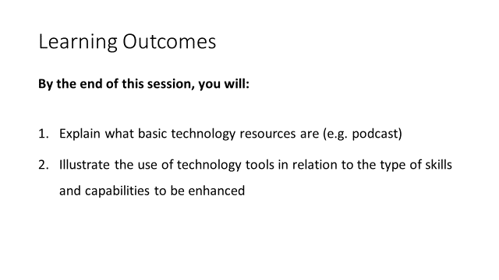
(1 min)

Facilitation: Introduce the learning outcomes of this session and make sure to address possible questions if there are any. You may highlight that this session will also enable learners to continue the reflection that was elicited in the previous session (session 2) on the type of learning enhancement supported by the use of technology. And, finally, they will also continue the discussion on the implications of technology for teaching.

Content: After having discussed the extent to which we can potentially enhance the learning experience by implementing technology in our learning design, we would now make sure that you refresh your knowledge of basic technology resources to enable you to think of, and choose, specific tools for specific pedagogical purposes and outcomes you want your students to achieve. In order to do that, this session will help you to explain what basic technology resources (such as podcasts) are, to illustrate the use of technology tools in relation to the types of skills and capabilities you would like to be enhanced.

You will also continue the reflection that was elicited in the previous session on the type of enhancement supported by the use of technology. And, finally, you will continue to discuss the implications of technology for teaching.

Formative Assessment: Setting clear expectations and outcomes is important to address possible questions at the very beginning of the course or session and avoid confusion.

Slide 3

(Total: 10 mins)

Facilitation: To prompt the reflection on technology implementation, introduce the pedagogy wheel. It is important to clarify that it should not be taken literally as some tools could be placed in a different section or in multiple sections and the focus should be on the learning rather than technology for the sake of it. Also, tools constantly change so those in the wheel could be easily replaced by others not available at the time.

Content: In order to prompt our reflection on how to effectively implement technology (i.e. in a pedagogically relevant way), we will now refer to the pedagogy wheel. The pedagogy wheel provides us with a framework (which should not be taken literally; as you can see some tools could be placed in a different section or in multiple sections and our focus should be on the learning rather than the tool itself) where the tools are mapped along with the Bloom’s Digital Taxonomy to help us visualise how specific technology tools could support the enhancement of specific skills. As we discussed throughout the day, technology per se can’t really do much; it is more the way we implement and exploit technology to make a difference in terms of potential learning benefits. It is important to keep this in mind as the tools suggested in the wheel are not always the best solutions, and the pedagogy wheel should be referred to in a rigid way, but rather as a supporting tool to elicit ideas and reflections during your design process.

This specific pedagogy wheel on the slide integrates also the SAMR model to the Bloom’s Digital Taxonomy and the tools. This is useful as we introduced the SAMR model in our previous session as a model to guide our process of technology integration.

The resource should, therefore, be used to encourage discussion and reflection on your current standards, on the role that technology plays in your teaching and to motivate you to explore technology tools that you might haven’t heard of.

Formative Assessment: Before moving to the next slide, it is recommended to assess learners’ understanding by posing questions or elicit their thoughts. Based on that assessment, the facilitator might decide to provide formative feedback and/or clarify possible areas of confusion.
Slide 4

(Slide: 2 mins)
(Activity: 20 mins)

Facilitation: Introduce the guidelines of the group activity and make sure everyone is clear on what they are expected to do. This activity would enable learners to independently learn about new technology tools (or refresh their knowledge of tools and re-elaborate their understanding to support their peers), and strengthen the connection between technology tools and the achievement of specific cognitive skills. Based on previous courses, the majority of learners had little knowledge of basic technology tools and terminology, so this session is crucial to reinforce learners’ understanding, and enable them to better choose tools for the technology enhanced activities they will be asked to design in the coming session. Having learners to actively cover this process through a group activity would avoid a more traditional lecture format, which would not allow learners to actively search for technology tools, test them out, and reinforce the links to their previous knowledge.

Content: (20 mins) In the coming activity, each group will be assigned to a single section of the wheel and with your peers you will be asked to research the tools or concepts mentioned in your section that none of your peers know of. Make sure you are able to introduce the tools of your section to the rest of the groups as you will be asked to do so at the end of your activity.

You will then design at least one activity using one or more of the tools included in the section of the wheel assigned to your group (or a different tool if you provide an explanation for your choice), and explain how the design of your activity supports the achievement of the skills of your section, and what type of enhancement and learning benefits it would support.

Formative Assessment: The facilitator would go around the groups, observe and listen to what learners say to make sure to provide quick and immediate formative feedback if needed. The group activity would also enable learners to learn from their peers.

Slide 5
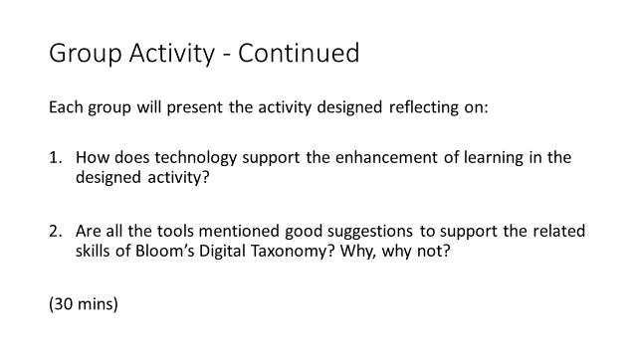

(Slide: 2 mins)
(Activity: 30 mins)

Facilitation: After the first part of the activity, ask each group to present the activity designed to the rest of the class, and to give a short overview of the tool chosen. This would allow to cover a few technology tools without overwhelming novices; also learners will be actively engage in the use and search of new technology tools and will learn from their peers.

It is recommended that you prepare a quick overview of a few tools (or technical terms or resources) that you consider important for them to know about in case they are not covered by any of the groups, and include them at the end of the group presentations.

Content: Now that with your group you search the technology tools and you have a better understanding of the section of the pedagogy wheel that you have been assigned, one member of your group is asked to present in maximum 5 minutes the activity you designed, providing a context to it. While presenting, take into consideration the questions on the slide, and explain how technology supports the enhancement of learning in your activity, why you choose that specific technology tool over the others suggested. Please also mention whether you think the tools recommended in your section were good ones to you or if your group could not imagine a potential use in that specific section.

Formative Assessment: The group activity would enable learners to learn from their peers, and would allow the facilitator to clarify or further deepen important concepts or tools mentioned during the group presentations.

Slide 6
