Researcher-led Approaches to Research
AURA Research Course 2

Course Pack
February, 2016

About the African Universities’ Research Approaches (AURA) Capacity Development Programme

The African Universities’ Research Approaches Programme (AURA) sought to strengthen research and teaching practices in East Africa through a blended learning approach – mixing online and face to face courses. AURA, a two-year programme, funded by UK AID, was implemented from November 2014 to September 2016 by the project consortium, consisting of: the Institute of Development Studies (IDS), the Information Training and Outreach Centre for Africa (ITOCA), and Loughborough University.
The overarching aim of the programme was to address continent-wide goals to support African universities to co-create a context-specific educational framework that would: address the need for locally generated research knowledge by skilled researchers (and graduates); and support faculty to nurture strong research and information capabilities by modelling how to create research-rich, and pedagogically innovative, teaching and learning environments.
AURA completed the following deliverables:
- The co-development of three research capacity courses that provided targeted support to academics (and students) to design, develop, and peer review, 5 responses to ‘live’ research calls, and strengthen current post-graduate research proposals
- Two teaching courses that strengthened capacity to design people-centred and technology-enhanced learning environments using evidence-informed teaching practices
- Application was a key aspect of the educational framework, and all participants were required to demonstrate comprehension of the course content through assessed course assignments, dialogic tasks and the development of curriculum enrichment plans.
- The programme took a cross-organisational approach by working with academics, technical and administrative staff in multi-disciplinary teams (called the ALIRT teams) to identify how to cost-effectively implement and support the achievement of institutional goals

The following educational framework is available to download through a creative commons license as individual course packs:
Three research courses:
- Orientation to different research approaches – known as R1
- Orientation to ‘researcher-led’, analytical research approaches - known as R2
- Research communications in social media – known as R4
Two teaching courses:
- Introduction to Teaching and Learning theory – known as T1
- Technology-enhanced learning approaches – known as T3
All of the course packs are aimed at educators in higher education institutions primarily in Africa but are also applicable to educators and other training/service providers in other parts of the world. Resources are can be re-used, adapted, or remixed (where indicated by the license) as long as the resulting materials are fully attributed.
AURA, a two-year programme, funded by UK AID, was implemented from November 2014 to September 2016.
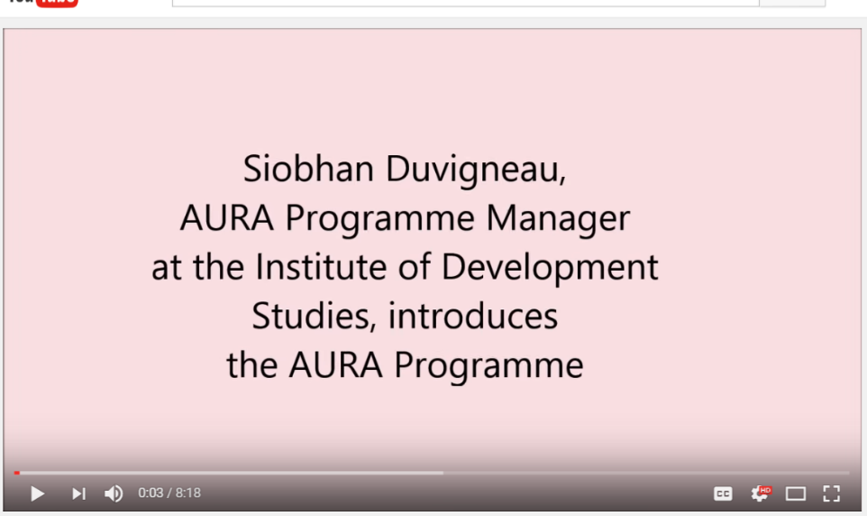
To watch the video [R2-V01], please click here: https://youtu.be/Yho7JFDwrpg
Siobhan Duvigneau, AURA Programme Manager, provides an introduction to the AURA Programme, to the consortium partners and participating partners from East Africa, and gives an overview of the aims and rationale of the programme.

The AURA Programme Consortium and Partners
The AURA Programme, led by the Institute of Development Studies in partnership with the Information Training and Outreach Centre for Africa and Loughborough University, worked with four universities - Jimma University, Kenyatta University, Muhimbili University of Health and Allied Sciences (MUHAS) and Strathmore University, and was aimed at academics working in health, business and other academic disciplines.

Acronyms

ALIRT | Academic department, Library, ICT Services, Research unit and Teaching unit
AURA | African Universities’ Research Approaches Programme
IDS | Institute of Development Studies, UK
ITOCA | Training and Outreach Centre for Africa
LMS | Learning Management System
LO | Learning Outcome
R1 | Research Course One
R2 | Research Course Two
R2_F2F-D1-S1 | Research Course Two Face-to-face Course-Day 1-Session 1
R2_PA-W1-S1 | Research Course Two Post Activity-Week 1-Session 1 (Post-Online Phase)
R2_PRA-W1-S1 | Research Course Two Pre Activity-Week 1-Session 1 (Pre-Online Phase)
R2-H01 | Research Course Two-Handout 01
R2-P01-S1 | Research Course Two-PowerPoint Presentation 01-Session 1
R2-R01 | Research Course Two-Reading 01
R2-TV01 | Research Course Two-Transcript 01
R2-V01 | Research Course Two-Video 01
R4 | Research Course Four
T1 | Teaching Course One
T3 | Teaching Course Three

List of Resources
Course Overview
Resource Unique Identifier | Title & Description
R2_Course Overview | Overview: AURA Research Course 2 (R2)
R2-V01 | Resource: Siobhan Duvigneau introduces the AURA Programme (course overview). Siobhan Duvigneau. AURA Programme Manager, provides an introduction to the AURA Programme, to the consortium partners and participating partners from East Africa, and gives an overview of the aims and rationale of the programme.  [Link: https://youtu.be/Yho7JFDwrpg]
R2-V02 & R2-TV02 | Dr Philipp Grunewald introduces R2 (video & transcript). The facilitator of R2 gives an overview of the course, which looks at analytical approaches to research, that is to say the research-led approaches, and how to implement them.  [Link: https://www.youtube.com/watch?v=mcGPKCaZXo8]
R2-V03 & R2-TV03 | Dr Philipp Grunewald introduces the pre-online phase of R2 (video & transcript), which is planned prior to the face-to-face course. He explains how the online space and collaboration among peers will be used, and that resources and activities are mostly planned for individual and independent work as a way of starting off the course.  [Link: https://www.youtube.com/watch?v=vRl66G2HyxI]
R2-V04 & R2-TV04 | Dr Philipp Grunewald introduces the face-to-face phase of R2 (video & transcript). He explains what learners will experience during the three face-to-face course, during which they will continue to work on their individual research proposal, on a funding call with their peers, and deepen their understanding of the three research methods introduced during the pre-online phase.  [Link: https://www.youtube.com/watch?v=6PCUiC9Q6mU]
R2-V05 & R2-TV05 | Dr Philipp Grunewald introduces the post online phase of R2 (video & transcript). In the video, the facilitator introduces learners to the final phase of the course, which is delivered online after the face-to-face course. Learners will revise and submit the methodology developed in response to the research call assigned during the course with their peers, and finalise their own research proposal.  [Link: https://www.youtube.com/watch?v=2uqAMP369p8]

Pre-Online Activities
Resource Unique Identifier | Title & Description
R2_PRA-W1-S1 | Session 1 Pre-online Activity (Week 1): Session plan. Guidance notes for facilitators/educators.
R2-V06 & R2-TV06 | Resource Session 1: Interview with Ayobami Ojebode on Comparative Case Studies (video & transcript). In this video, Ayobami Ojebode, lecturer and researcher in media, democracy and development at the University of Ibadan, defines comparative case studies, and describes the different types of comparative case studies, which can be descriptive or causal.  [Link: https://www.youtube.com/watch?v=Fujkc3KxAFI ]
R2-V07 | Resource Session 1: Better User Research Through Surveys (video). In this YouTube video, learners will find suggestions by Chris Gray on how to design good quality surveys and specific types of questions to gather relevant data.  [Link: https://www.youtube.com/watch?v=bi2JMRpL9Ik]
R2-V08 | Resource Session 1: Basics of designing a survey (video). This YouTube video is made by The Center for the Study of Student Life is in the Office of Student Life at the Ohio State University. It is about the basics of survey design in higher education settings, and covers the basics of designing a survey, with an emphasis on higher education and student affairs contexts.  [Link: https://www.youtube.com/watch?v=36s6wBSJW8U ]
R2-V09 & R2-TV09 | Resource Session 1: Interview with Dr Getu Ambaye Teshale on Social Network Analysis (video & transcript). In this video, Dr Teshale, lecturer at the University of Gondar, explains why he finds the use of social network analysis particularly relevant to identify critical, and crucial problems within the community. He argues that SNA is a good tool to identify the kinds of problems affecting poor communities in urban settings, among other positive aspects of this research method.  [Link: https://www.youtube.com/watch?v=nXJ0_18vFCA ]
R2-V10 | Resource Session 1: Basics of Social Network Analysis (video). In this video Dr Nigel Williams explores the basics of Social Network Analysis (SNA): Why and how SNA can be used in Events Management Research.  [Link: https://www.youtube.com/watch?v=PT99WF1VEws ]
R2-V11 & R2-TV11 | Resource Session 1: Interview with Daniel Doh on Concepts and Typologies (video & transcript). In this video, Daniel Doh, research fellow at the Centre for Social Policy Studies at the University of Ghana, talks about concepts and concept formation when conducting research.  [Link: https://www.youtube.com/watch?v=f2Eh0chWdPM ]
R2-H01 | Handout Session 1: Present your research proposal. This handout provides a template that learners are asked to fill out to clarify the aims and outcomes of a research project that they are currently working on or a research topic that they would like to start working on during the course.
R2-H02 | Handout Session 1: Reading list. This handout provides a reading list that serves as a starting point for learners’ continuous enquiry and development of their research capacity. Section one suggests general readings related to researcher-led research, while section two to four focus on three research methods that are of particular relevance to the course. It is recommended to share this bibliography prior to the face-to-face course to help learners familiarise with the course content according to their different learning needs and preferences.
R2-H03 | Handout Session 1: Rubric for Discussion Forum Participation. This handout provides a rubric that could be used by learners as a tool to self-assess the quality of their participation in the online discussions as well as by facilitators to provide guidance in promoting quality contributions to online discussions.
R2_PRA-W2-S2 | Session 2 Pre-online Activity (Week 2): Session plan. Guidance notes for facilitators/educators.
R2-H03 | Handout Session 2: Rubric for Discussion Forum Participation. This handout provides a rubric that could be used by learners as a tool to self-assess the quality of their participation in the online discussions as well as by facilitators to provide guidance in promoting quality contributions to online discussions.

Face to Face Activities

Resource Unique Identifier | Title & Description
R2_F2F-D1-S3 | Session 3 Face to Face Course (Day 1): Session plan. Guidance notes for facilitators/educators.
R2-P01-S3 | Power Point Presentation Session 3: Introduction Workshop & Outcomes. This presentation provides guidance for Session 3 as an introduction to the course outcomes, to the ice-breaker activities, the rules of the course, and the formative assessment technique (e.g. mood monitor) which will form part of the course.
R2_F2F-D1-S4 | Session 4 Face to Face Course (Day 1): Session plan. Guidance notes for facilitators/educators.
R2-P02-S4 | Power Point Presentation Session 4: Write a scenario where a researcher-led approach to research is more appropriate. In this presentation, the learning outcomes of the session are presented. In addition, guidelines and prompting questions are provided to facilitate a group activity, where learners are asked to write a scenario that is more appropriate for research-led approaches to research
R2_F2F-D1-S5 | Session 5 Face to Face Course (Day 1): Session plan. Guidance notes for facilitators/educators.
R2-P03-S5 | Power Point Presentation Session 5: Deconstruct three research methods. In the presentation, the learning outcomes of the session are presented. In addition, reflective questions are provided for facilitators to provide learners with three mini lectures on the three research methods presented in this session: case studies; survey and social network analysis. The presentation also provides guidance for a group activity to deconstruct the three research methods previously introduced by the facilitator.
R2_F2F-D1-S6 | Session 6 Face to Face Course (Day 1): Session plan. Guidance notes for facilitators/educators.
R2-P04-S6 | Power Point Presentation Session 6: Reflect on third party methodology & diagram. The presentation introduces learners to the session’s learning outcomes, and provides them with an example of a diagram created by a learner who attended R2 to illustrate a third party methodology.
R2_F2F-D1-S7 | Session 7 Face to Face Course (Day 1): Session plan. Guidance notes for facilitators/educators.
R2-P05-S7 | Power Point Presentation Session 7: Reflective Practices. This presentation provides activities to introduce learners to reflective practices and to writing reflective journals, which is a compulsory task required in all the courses delivered by the programme. That is why the presentation is “universal” and requires to be tailored to different contexts and audience (e.g. educators or researchers).
R2_F2F-D2-S8 | Session 8 Face to Face Course (Day 2): Session plan. Guidance notes for facilitators/educators.
R2-P06-S8 | Power Point Presentation Session 8: Introduction to Day 2 and its objectives. The presentation outlines the learning outcomes of the session, and guides the facilitator through a quick recap of what was covered during the previous day, prompting learners to share their reflections.
R2_F2F-D2-S9 | Session 9 Face to Face Course (Day 2): Session plan. Guidance notes for facilitators/educators.
R2-P07-S9 | Power Point Presentation Session 9: Deconstruct your own methodology. The presentation outlines the learning outcomes of the session, and provides guidelines for the group activity ‘Introduce your own methodology.’ Guidelines are also provided for three sprints on comparative case studies, survey, and social network analysis.
R2_F2F-D2-S10 | Session 10 Face to Face Course (Day 2): Session plan. Guidance notes for facilitators/educators.
R2-P08-S10 | Power Point Presentation Session 10: Design research proposals in groups. This presentation outlines the learning outcomes of the session, and provides guidelines for the main group activity of the R2 course. Learners are asked to design a research proposals in groups in response to a funding call. This presentation guides learners through a scaffolded activity to form transdisciplinary teams, choose their preferred theme and group, and finally form the group they will work with to respond to a funding call.
R2_F2F-D3-S11 | Session 11 Face to Face Course (Day 3): Session plan. Guidance notes for facilitators/educators. Guides the group presentations, and peer feedback process, on research proposals.
R2-P09-S11 | Power Point Presentation Session 11: Introduction to Day Three and its objectives. This presentation outlines the learning outcomes of the session, and guides the facilitator through a quick recap of what was covered during the previous days, prompting learners to share their reflections.
R2-H04 | Handout Session 11: Rubric for peer assessment activity. This handout provides a rubric that learners will be asked to use during the post online phase of R2 [see R2-H05 & R2-H07]. In Day 3, it is recommended to introduced it to make sure learner are clear on what they are expected to do and how to best provide relevant feedback to their peers.

Post-Online Activities
Resource Unique Identifier | Title & Description
R2_PA-W1-S12 | Session 12 Post online Activity (Week 1): Session plan. Guidance notes for facilitators/educators.
R2-H05 | Handout Session 12: Rubric for peer assessment activity. This handout provides a rubric that learners will use during week 2 of the post online phase of R2, to peer assess the groups’ final methodology developed in response to a funding call. In Week 1, learners are recommended to refer to this rubric while finalising their proposal to make sure they cover the areas they will be assessed on by their peers in Week 2.
R2-H06 | Handout Session 12: Rubric for Reflective Journal feedback. This handout provides a rubric that the facilitator will use to assess learners’ final reflective journal. Learners can refer to this rubric while finalising their journal to make sure they cover the essential areas they will be assessed on, and as a self-assessment tool.
R2_PA-W2-S13 | Session 13 Post online Activity (Week 2): Session plan. Guidance notes for facilitators/educators.
R2-H07 | Handout Session 13: Rubric for peer assessment activity. This handout provides a rubric that learners are asked to use to provide constructive feedback to their peers during week 2 of the post online phase of R2. It is recommended that the facilitator introduces the rubric during Day 3 to make sure learners are clear on what they are expected to do (refer to R2-H04 for the face-to-face course).
R2-H08 | Handout Session 13: Rubric to assess learners’ own methodology and related diagram. This handout provides a rubric that the facilitator will use to assess the final methodology and diagram produced individually by learners (which was submitted as a draft during the pre-online phase). Learners can refer to this rubric while finalising their proposal to make sure they cover the essential areas they will be assessed on, and as a self-assessment tool.

Process Definition

AURA R2 – Researcher-led Approaches to Research - comprises three main components, namely two online phases delivered before and after a three day face-to-face course, which have been organised in 13 sessions.
Each session file contains the following:
- Overall Description and indicative time of delivery
- Learning outcomes
- Recommended modality (i.e. face-to-face or online)
- Overview of the main learning activities
- Formative assessment strategies
- Course material recommended to deliver the session
- Presentation’s slides with facilitation instruction (text in bold), a script for the facilitator as a support for the delivery of the session (text in italics), and a section on the formative assessment techniques recommended (text underlined)

The course content was organised into independent sessions, discrete units that users could pick and choose from, without necessarily having to deliver the entire course. This cost-effective approach to e-learning aimed to design objects that future users could easily re-use, edit, and tailor to different contexts, levels of expertise, and target audiences. However, a significant level of dependency among the sessions of the course is preserved and made explicit in the facilitation instructions.
R2 builds on what covered during R1. Therefore, the design of the course is based on the requirement that only those who attended R1 could then move to R2. If this is not the case, it is strongly recommended to add activities to cover the concepts and knowledge of R1 before having learners to engage with the content and activities planned for R2.

Research Course Two (R2): Overview

R2 focuses on researcher-led approaches to research, and aims to help learners with their practice as academics and researchers. While R1 looked at analytical and holistic approaches to research, their philosophical underpinnings and the way they generally shape our behaviour as researchers, in R2 learners will engage with analytical approaches to research.

The course runs over 6 weeks, and starts with a two week pre-online phase where learners engage with asynchronous activities and discussions with their peers around different topics. In the second phase, they attend a three day face-to-face course, which would end with a final two week post-online phase.

The course is designed around four general themes. One of the themes is based around content, and focuses on the actual information and knowledge that learners will need to be aware of in order to apply researcher-led approaches to research. This will include materials around comparative case study analysis, surveys and social network analysis, in particular, but also we’ll be considering other methods and broader approaches to researcher-led type research. Then learners will look at three further streams of activities. One will be focused around their own research and beyond their own proposals and ideas for research, and will run across all the phases of the course.

The next thing will be engagement with third party research methodologies. So, we will be looking at research methodologies that people have applied that are researcher-led type research approaches to conducting research projects, and analysing the phenomena that they are interested in. The last theme, will involve a high degree of engagement with one other, and part of this will explore the peer element, where you will be working with each other (and with myself and other facilitators) around research calls.

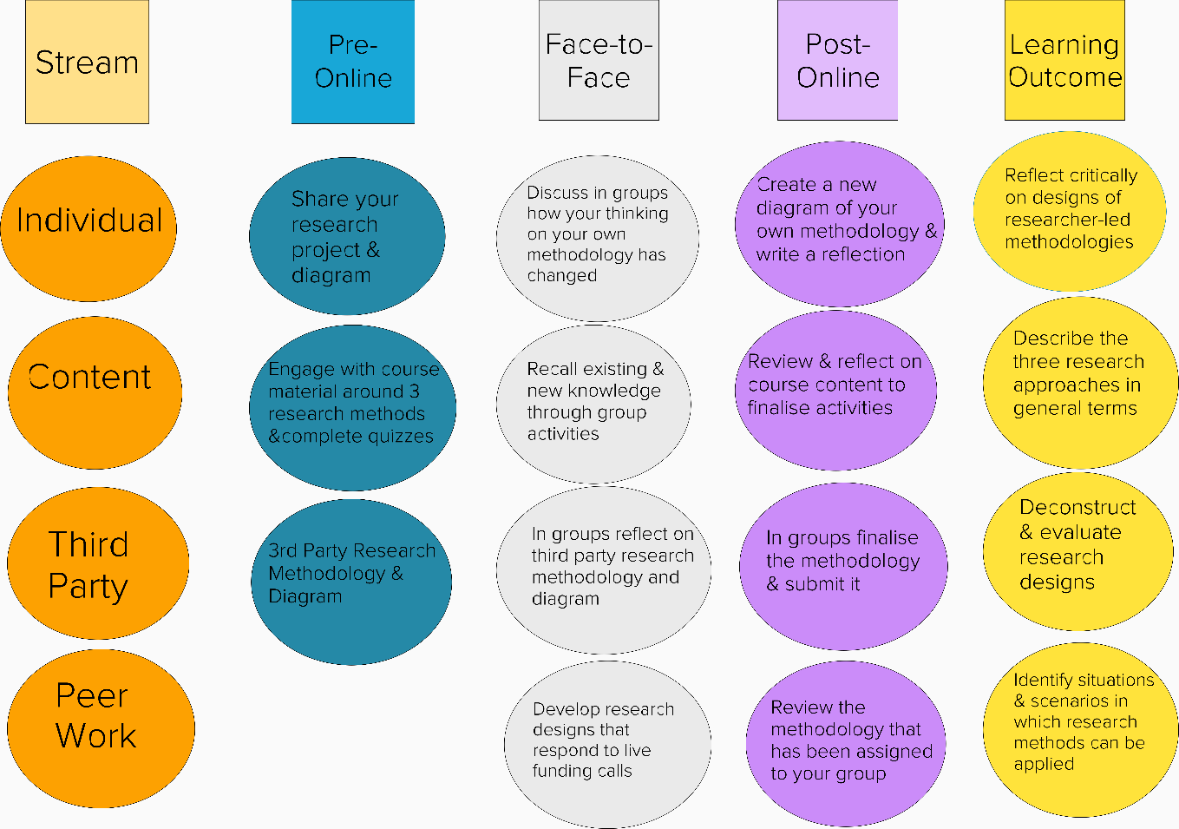
The diagram shows the dependencies among the learning activities designed for R2
In the video below [R2-V02 & R2-TV02], Dr Philipp Grunewald, facilitator of R2, gives an overview of the course and clarifies the four general themes (i.e. individual, content, third party and peer work).

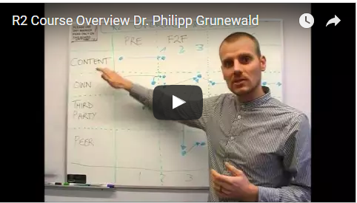
To watch the video [R2-V02 & R2-TV02], please click here: https://www.youtube.com/watch?v=mcGPKCaZXo8

Blended Learning – The Approach

AURA Research Course 2 applies a flipped classroom approach, according to which most instructional content is delivered online. Learners engage with the course content online to have more face-to-face time for application and thus reduce lecturing time. A crucial aspect of this approach, which is a type of blended learning, is the dependency between online and face-to-face activities that are interconnected and strictly related towards the achievement of the learning outcomes. As a consequence, the completion of at least the compulsory activities planned for the online phase is a requirement in order to be able to attend the face-to-face course and fully interact with the activities planned for remaining of the course.

Full participation in online discussions is achieved based on the quality of participants' contribution. A rubric has been designed to clarify the importance of criteria such as: quality and timeliness; mechanics; demonstration of understanding and knowledge of content; and generation of learning within the community.

Blended Learning – Technical Aspects

Research Course Two adopts a blended approach, in which a face-to- face course was planned between two online phases; a self-directed online phase prior to an experiential three day face-to- face course, and a final online phase to apply the skills and knowledge acquired and further reflect on the learning experience.
In the sessions of R2, the suggested modality is indicated based on this delivery model. However, we encourage the users of this course pack to reflect on their own learning environment and contextualise the materials to fit their learning context. The duration of the sessions is also indicative and can be expanded if the sessions are delivered in a context that allows for more time.
In order to share course material with learners, it is recommended to choose an online learning platform considering aspects such as such as usability, scalability, pricing, technical and pedagogical aspects.
It is important to take into consideration that learners should be able to access the learning materials once the course has ended or they should be able to easily store the material (availability).
The learning platform should provide learners with a secure environment; therefore, it is advised to reflect on whether the online environment should be public or private and related positive and negative aspects of both options (security). Either ways, participants should be made aware of the status of the learning platform they work in and whether their contribution is shared with the peers only or with a wider audience.
A learning platform should be chosen based on a needs’ assessment process, considering some of the aspects mentioned earlier. It is recommended to pilot the platform chosen, and collect feedback from a small population of users before launching it.
Regardless of the online platform chosen to host the course, it is strongly recommended to provide learners with an introductory training session, and continuous technical support throughout the course. Resources, such as short video tutorials and handouts, should also made available to learners in addition to synchronous online or face-to-face training sessions.
The learning platform should be well organised and the course resources should be preferably in the same location. Nevertheless, the structure should not be too rigid and attendees should not be required to go through all course material in a specific order. "Novice learners frequently do not know what they do not know, but experts frequently have a pretty good idea. You can trust them to get the information they need if you make sure that it's easily available and applicable" (Dirksen, 2011). To make sure that the site structure follows this principle, it is recommended to implement a flexible, yet organised, structure. Below a few suggestions:
- Have a short introduction to each of your resource to allow participants to know whether they want to look at it or not without having to ‘open’ it.
- Clarify which resource is compulsory or elective.
- Organise content per topic rather than week/day/period
- Organise similar resources in folders and clearly denominate them
- Make sure your attendees have time to work on their own problems and to relate the course material to their work/research interest and reinforce their understanding through activities (compulsory and elective) that cover that content.
- Create short videos of max 10-15 minutes. The attention spam, especially for a teacher-centred lecture format, is not longer than 5 minutes, so it is recommended to have short chunks of videos even on the same topic.
- Write a short introduction to any videos (or more generally to any course resource) you upload to your online platform to facilitate participants in the selection of the resource they wish to see. Provide a transcript and subtitles to make sure your resource is easily accessible to a diverse audience with different needs (usability & flexibility).
- Agree with interviewees on the questions you would like to ask. Make sure you divide a topic(s) in subtopics with different questions so that you can edit them and have shorter videos.

In order for attendees to engage and familiarise with the courses content, it is important to provide them with opportunities to reflect and elaborate on it with their learning peers. Interactive online discussions are recommended. The process of creating discussion forums varies depending on the online platform chosen.
Regardless of the tool, it is recommended to include a short prompt to introduce and clarify the topic discussed in that particular thread, specific details concerning the length of each response, and its assessment (if it applies). This prompt would be located under the title of the threat to make sure participants can choose the conversation they want to take part in.

Reference:
Julie, Dirksen. Design for How People Learn (Voices That Matter), New Riders, 2012.

Pre Face-to-face Online Phase: Overview

In continuation from R1, and as its pre-requisite course, Research Course Two (R2) aims to deepen learners' understanding of researcher-led research, and to develop the skills necessary for the practical implementation of such research projects.

The pre-online phase of R2 runs over two weeks prior to the three day long face-to-face course. During that time, attendees can actively engage with the course material as well as develop their understanding of researcher-led approaches to research through activities that are mostly individual and that can be completed asynchronously.

In the first week of the pre-online phase, learners are asked to share their own research project with the facilitator (compulsory activity). This is the beginning of a learning journey that will encourage learners to reflect on, deconstruct and re-construct their own project and its methodology. The course content and the activities planned throughout the course are designed to support this process. The research project submitted in this initial phase will be revised during the face-to-face intervention and finalised and submitted during the post-online phase.
This intervention applies a flipped classroom approach. Learners can rely on online engagement with course content to have more face-to-face time for application and thus reduce lecturing time. A crucial aspect of this approach, as well as of the blended model chosen, is the dependency between online and face-to-face activities that are interconnected and strictly dependent towards the achievement of the learning outcomes. As a consequence, the completion of some of the online activities is "compulsory" and required prior to the beginning of the face-to-face course.

The activities cover crucial concepts needed for learners to be able to actively engage with (and attend) the face-to-face course and post-online phase in accordance with a flipped classroom approach.

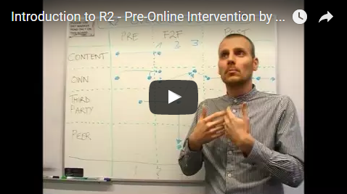
To watch the video please click here: https://www.youtube.com/watch?v=vRl66G2HyxI

In the video above [R2-V03 & R2-TV03], Dr Philipp Grunewald, facilitator of R2, introduces the pre-online phase of the course, which was delivered prior to the face-to-face course. He explains how the online space and collaboration among peers will be used, and that resources and activities are mostly planned for individual and independent work as a way of starting off the course.

Overall learning outcomes:
- Identify situations and scenarios in which researcher-led approaches are appropriate.
- Recall existing knowledge of quantitative research methods and techniques.
- Conduct a systematic meta-analysis of a field of study.
- Describe three research approaches in general terms (surveys, comparative case studies, social network analysis); including the analytic trade-offs each makes, and what they can and cannot do.
- Identify situations and scenarios in which the three research approaches can be applied; e.g. by giving examples.
- Design methodologies that gather qualitative data in a systematic manner.
- Develop mixed methods methodologies.

Overall learning objectives:
- Deconstruct research designs (researcher-led) and evaluate their likely strengths and weaknesses.
- Think and reflect critically on designs of researcher-led methodologies.
- Judge the value of the methods to your own research interests and questions.

Face-to-face Course: Overview

The face-to-face course is planned for delivery over three days.

During Day 1, learners get to know one another and each other's research projects by presenting the methodology they were asked to choose and submit during the pre-online phase. This is followed by a discussion on possible scenarios in which the researcher-led approach might be appropriate.

A theoretical background on research methods, provided during the pre-online phase, is reinforced with a group activity around social network analysis, surveys, and comparative case studies. In groups, learners share their reflections on the third party research methodology and on the diagram they created during the pre-online intervention to illustrate it, discussing its weaknesses and strengths. Day 1 ends with learners’ individual reflections to elaborate on what they learned and how that influenced their own research design.
During Day 2, learners further reflect on their own methodology and research project chosen during the pre-online phase; they are asked to present their methodology to their peers in groups and receive constructive feedback.
Participants engage with three sprints (intensive periods of concentration of group work), where they look at how comparative case studies, survey and social network analysis may feed in and may be applied in the context of their own project and methodology.
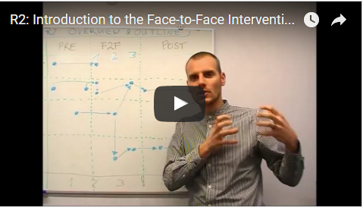
To watch the video please click here: https://www.youtube.com/watch?v=6PCUiC9Q6mU

Transdisciplinary teams then start to collaborate on the design of a researcher-led methodology that responds to a funding call. This activity continues during Day 3 of the face-to-face course; learners are prompted to reflect critically on designs of third party researcher-led methodologies and on the value of the methods to their own research. This should help them think how they might want to change their own methodology and/or continuously improve it.
During Day 3, learners present the call assigned to their group, and their related drafted proposal, to the learning community and receive constructive feedback from their peers, which will then be implemented towards a final draft to be submitted by the end of week one of the post-online intervention.
Furthermore, they individually capture their experience on how R2 influenced their own approach to research in a reflective journal, which will be finalised later on, and submitted, during the post-online phase. Finally, participants continue this reflective process within their groups to deconstruct and critique how their thinking on their own methodology has changed over the last two days.

Overall learning outcomes:
- Describe the three research methods in general terms (i.e. Comparative Case studies, Social Network Analysis, Surveys); including the analytic trade-offs each makes, and what they can and cannot do
- Identify situations and scenarios in which they can be applied
- Deconstruct research designs (that use these methods) and evaluate their likely strengths and weaknesses
- Design researcher-led research methodologies that answer their own research and funding bodies' questions by using the covered (and other) methods

Overall learning objectives:
- Judge the value of the methods in relation to your own research
- Think and reflect critically on designs of researcher-led methodologies
- Judge the value of the methods to your own research interests and questions

Post Face-to-face Online Phase: Overview
The post-online phase runs over two weeks.
During week one, learners continue to work in transdisciplinary groups to finalise the methodology they developed in response to the research call assigned during the face-to-face course, and to incorporate the peers' feedback that they received on Day 3 of the face-to-face course. The group methodology has to be submitted by the end of week one as this is a pre-requisite for completing the other activities planned for week 2.
During week two, groups are asked to work across institutions. Each group is assigned to assess a drafted research call from one of the other teams by providing feedback agreed among all the team members (i.e. they have to discuss as a group during the post online).
In week 2 of the post-online intervention, learners continue to review in groups a methodology that was assigned to them from the other institution, to provide constructive feedback for improvement and to reach a decision about funding/not funding the project.
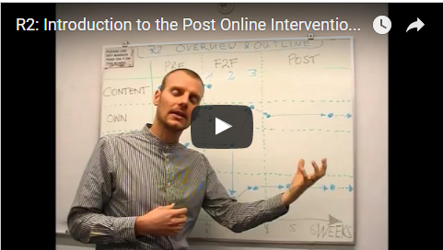
To watch the video please click here: https://www.youtube.com/watch?v=2uqAMP369p8

Overall learning outcomes:
- Explain your journey and analyse how what you learned, and reflected on, during R2 did, or did not, influence your own research design in terms of skills, attitude and behaviour
- Manage design of researcher-led approaches and methodologies in transdisciplinary teams
- Deconstruct and peer assess research designs (researcher-led) and evaluate their likely strengths and weaknesses
- Manage design of researcher-led approaches and methodologies in transdisciplinary teams
- Design your own researcher-led research methodology

Overall learning objectives:
- Judge the value of the methods in relation to your own research
- Think and reflect critically on designs of researcher-led methodologies
- Judge the value of the methods to your own research interests and questions

