Research Course 1/Face-to-Face /Day 3/Session 14 (R1_F2F-D3-S14)
Title: Contextualise your research
Session Description:
(Overall time: 30 mins) The purpose of this session is to enable learners to justify their research within a theoretical/epistemological context and appreciate the need to contextualise their research. In so doing, their research would have value from an academic point of view and could be publishable in an academic journal. Learners will experience how to contextualise their research through an activity, during which they will identify different realities on a continuum and reflect on where they would place their research within a specific world view and epistemology, and how they would explain and justify the methodology they proposed to take.

Learning Outcomes:
- Justify your research within a theoretical/epistemological context
- Appreciate the need to contextualise your research
Recommended Modality:
- Face-to-face
Learning Activities:
- (20 mins) Learners will watch the online lecture by Jethro Pettit that was assigned as compulsory activity during the online phase to refresh their memory and to be able to identify the research paradigms highlighted by Pettit (LO 2)
- (30 mins) A group activity that enables learners to identify the research paradigms and plot them on the continuum provided to then locate their own research on that continuum (LOs 1-2)
Formative Assessment:
- Questioning
Learning Resources:
- [R1-P13-S14] Power Point Presentation Session 14: Contextualise research. This presentation outlines the learning outcomes of the session, and support learners’ reflection through a guided activity on identifying research paradigms.
Course Materials:
- Post-it notes
- Pens
- Projector
- Computer

Presentation Slides
Slide 1

Points in bold are facilitation instruction - for example, they might indicate how to run a group discussion or brainstorming session.

Points in italic indicate things you should tell the audience. You can express them in your own words.

Underlined points refer to formative assessment techniques and indicate what you can learn from learner responses (although it is impossible to be comprehensive about all of the insights).

Slide 2

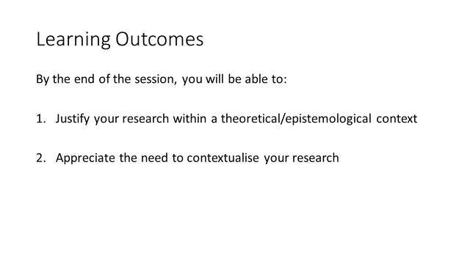
(2 mins)

Facilitation: Clarify the purpose of this session while showing the learning outcomes on the slide.

Content: The purpose of this session is to enable you to justify your research within a theoretical/epistemological context and appreciate the need to contextualise your research. In so doing, your research would have value from an academic point of view and could be publishable in an academic journal.

Formative Assessment: N/A

Slide 3

(5 mins)

Facilitation: The facilitator should make explicit if he/she is coming from a science background, which tends to assume a positivistic orientation (discussed later) but he/she would also want to draw on social science methods and techniques, for example in the area of public health, and take a mixed methodological approach highlighting the importance of appreciating the perspectives of a range of research orientations.

For instance clarify that if learners collaborate with researchers from other disciplines such as sociologists or anthropologists, it is important to be able to understand their orientation, their epistemological / philosophical background and why they use certain methodologies (e.g. participative approaches).

Emphasise the importance of contextualising ones’ research within contemporary research paradigms (i.e. positivist / interpretivist way of viewing the world) with a short explanation of what contextualising one’s research means.

Content: Contextualising one’s research within the academic context means that firstly you need to place it within a specific world view and epistemology, and then, you need to explain and justify the methodology you proposed to take. However, the focus of your study needs to also explicitly either build on previous research (for example filling a gap) or be shown to contribute a new research insight. In other words, critically reflect on previous research or add new insights.

Formative Assessment: The facilitator should make sure of learners’ understanding by asking questions and address possible areas of confusion by allocating additional time to this introduction.

Slide 4

(Video and discussion: 20 mins)

Facilitation: Show on a screen, the 14-minute presentation of Jethro Pettit. Clarify that you are showing the video again as some time has passed from the online phase. Since this activity was assigned as compulsory in the online phase, it might be good practice to mention some comments shared by learners on the online discussion forum to prompt discussion, and acknowledge their participation while refreshing their memory of the topic.

Before starting the activity, ask participants what research paradigm they have heard during the presentation, and to share them with the wider group (orally)

Content: Before learning how to contextualise your research, we will watch the presentation of Jethro Pettit since some time has passed and it was an elective activity.

I would like to know what research paradigms you have heard during the presentation.

Formative Assessment: This activity would enable the facilitator to determine the knowledge of learners, clarify areas of confusion and assess whether more time is needed on this topic before proceeding to the next activity.

Slide 5

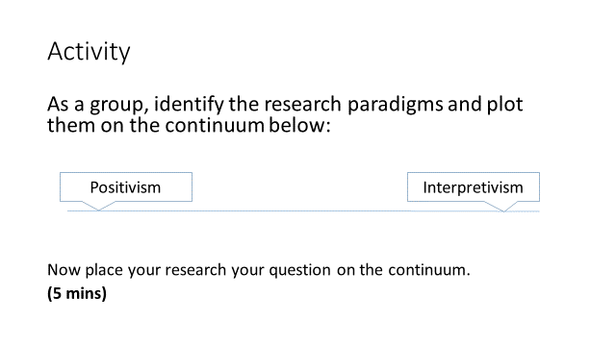

(5 mins)

Facilitation: After eliciting a short discussion on the research paradigms mentioned in the previous video, ask participants to construct – as a whole group - the continuum, then to place the subcategories that the facilitator has written on post-it notes (created before the session by the facilitator) and finally invite a representative of each group to place their research questions (critical realism, social constructivism and phenomenology) on the continuum.

The facilitator can show an example of research paradigms as comparison to what the participants have come up with. The continuum, from positivism/well defined outcome reality to interpretivism, includes the subcategories below:
- Positivism
- Critical realism (towards positivism)
- Social constructivism (towards interpretivism, it is a part of it, a flavour of it)
- Phenomenology (towards interpretivism)
- Interpretivism

Content: Refreshing our memory on research paradigms is useful as we will now construct – as a whole group - a continuum, from positivism/well defined outcome reality to interpretivism. You will identify the subcategories that I have written on post-it notes and place them on the continuum. Then everyone will place their research questions you have written on the continuum (a continuum that includes critical realism, social constructivism and phenomenology).
(After the activity) Finding research paradigms might help you identify research paradigms used by other authors. In the coming session we will learn how to identify what paradigms other authors are using.

Formative Assessment: This activity would enable the facilitator to determine the knowledge of learners, clarify areas of confusion and assess whether more time is needed on this topic before proceeding to the next activity.

Slide 6

