Research Course 1/Face-to-Face /Day 1/Session 6 (R1_F2F-D1-S6)
Title: How we categorise phenomena using an analytical approach
Session Description:
(Overall time: 60 mins) The purpose of this exercise is to guide learners through an experiential activity that enables them to identify analytical approaches to the definition of phenomena. Learners will experience the difference between analytical and holistic processes, the different languages the two use to define the phenomena, and the possible benefits of applying a participatory approach to define phenomena.

Learning Outcomes:
- Relate to and explain the analytical approach
Recommended Modality:
- Face-to-face
Learning Activities:
- (60 mins) A rose: a botanical perspective: in groups, learners cover a different set of questions and then report to the wider group (LO 1)
Formative Assessment:
- Questioning
- Peer feedback
Learning Resources:
- [R1-P05-S6] Power Point Presentation Session 6: A rose - a botanical perspective. This presentation outlines the learning outcomes of the session, and provides guidelines and prompting questions for the experiential activity to enable participants to experience the analytical approach.
Course Materials:
- Computer
- Projector

Presentation Slides
Slide 1

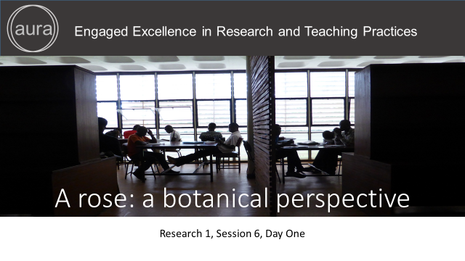

Points in bold are facilitation instruction - for example, they might indicate how to run a group discussion or brainstorming session.

Points in italic indicate things you should tell the audience. You can express them in your own words.

Underlined points refer to formative assessment techniques and indicate what you can learn from learner responses (although it is impossible to be comprehensive about all of the insights).

Slide 2

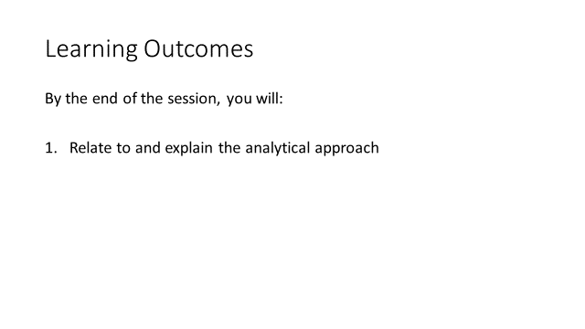
(1 min)

Facilitation: Introduce the session by making the connection between this and the previous session explicit, and clarify to learners that through the activities they are reflecting on how they categorise phenomena using an analytical approach.

Content: Through another activity you will experience how to relate to and explain the analytic approach.

Formative Assessment: N/A

Slide 3

(Slide 3-4: total 5 mins)

Facilitation:
Show the examples on the slides 3 & 4 (5 min), and then move to the reflective activity in groups (slide 5).

Content:
Look at the slides (3 & 4) with two examples of taxonomic classification that categorise a rose and maize and identify the classifications for the following: Domain, Kingdom, Order, Family, and Species.

Formative Assessment: N/A

Slide 4

(Slide 3-4: total 60 mins)

See slide 3

Slide 5

(30 mins)

Facilitation: Divide participants into groups of max 4 members and assign them 1 to 2 questions among those listed per group. Each group will cover a different set of questions and then report to the wider group. Ask them to reflect and answer to the questions and then share their collective answers with the whole group.

Possible answers to some of the questions are suggested below:
- Whose voice is defining the phenomena? Is this researcher-led or citizen-led? Possible answer: It is researcher-led, the expert is using a scientific language to categorise the phenomena
- Could you classify a rose using a pre-defined taxonomy as part of a participative process? Possible answer: They would have to become familiar with the experts taxonomy unless if they have developed their own taxonomy as a community.
- Would you describe this as a holistic or analytical process? Possible answer: This would be an analytical process and not holistic
- What kind of data are we gathering? Quantitative
- How could it be analysed? Possible answer: Analysing the characteristics according to the taxonomy for example the number of petals on a rose. Botanically the features of the flower could be categorised accordingly.
- What are the benefits of applying this approach? Possible answer: The plant can be analysed using certain criteria which has been agreed by the community of practice. i.e. Botanist. The benefits of this is that they agree to use a shared language that enables them to categorise and predict the properties of things (plants) which also enable people to cultivate and manage these things (plant).
- Is it something that can be explored in an analytical way or a holistic way? Possible answer: Each approach have their merit and each would tend to be more or less qualitative or quantitative in nature.

Please consider that the discussion could extend to the value of people being able to generalise and make predications in terms of concrete examples particularly in relation to the cultivation of plants that have various uses, properties, needs, and diseases which has enabled us to make huge advances by applying a scientific, analytical approach over the last 3-500 years especially.
After the activity, the facilitator might want to highlight that this useful, standardised approach can be applied by many ‘experts’ to observe distinctions between different objects as well as make predictions that shows that certain classes of objects are recognised as having implicit properties.

Content: In group of max 4 members, reflect on the questions that are assigned to your group among the following:

- Whose voice is defining the phenomena? Is this researcher-led or citizen-led?
- Could you classify a rose using a pre-defined taxonomy as part of a participative process?
- Would you describe this as a holistic or analytical approach?
- What kind of data are we gathering?
- How could the data be analysed?
- What are the benefits of applying a participatory approach?
- Is it something that can be explored in an analytical way or a holistic way?

(At the end of the activity) I would like to highlight that this useful, standardised approach can be applied by many ‘experts’ to observe distinctions between different objects as well as make predictions that shows that certain classes of objects are recognised as having implicit properties.
Formative Assessment: sharing reflections within groups will allow learners to give and receive constructive peer feedback.

Slide 6

Slide 7

