Research Course 1/Face-to-Face /Day 1/Session 5 (R1_F2F-D1-S5)
Title: The Analytical & Holistic Approach
Session Description:
(Overall time: 140 mins) The purpose of this session is to help learners identify a distinctive analytical approach to research writing using the language of ‘science,’ and thus experience the distinction between analytical explanations and experiencing a phenomenon. The distinctive language of science that reflects a highly analytical approach which breaks things down into discreet parts might be different from our experience of a phenomenon. In this session, learners will focus on language and text, in contrast to the previous session during which we focused on visual imagery.

Learning Outcomes:
1. Identify a distinctive analytical approach to research writing using the language of ‘science’
2. Experience the distinction between analytical explanations and experiencing a phenomenon
Recommended Modality:
- Face-to-face
Learning Activities:
- (10 mins) An individual reflection on Paul Churchland’s quote and the way he describes one way of observing a phenomenon. Learners will then share their idea with their team members in groups (LO 1)
- (80 mins) In the Phenomenological Approach Exercise, learners will be blindfolded and given two objects that they will be asked to hold, touch, smell, and taste to guess what they are. This experiential exercise will elicit their reflection on the essence of the phenomena (LO 2)
- (40 mins) In the collective intelligence exercise learners will learn to map concepts, and connect people’s conceptual maps. The exercise illustrates the inter-subjectivity of the group experience and the emergence of patterns based on individual sensing (LO 2)
- (10 mins) A final individual and group reflection on the experiential exercises that learners have completed during the session to connect what experienced to their own research (LOs 1-2)
Formative Assessment:
- Questioning
- Constructive feedback provided by the facilitator
- Peer feedback
Learning Resources:
- [R1-H02] Handout: The Analytical Approach - Quote by Paul Churchland. This handout provides a quote by Paul Churchland describing one way of observing a phenomenon.
- [R1-P04-S5] Power Point Presentation Session 5: The Analytical & Holistic Approach - This Power Point presentation outlines the learning outcomes of the session, and provides guidelines and prompting questions for the individual and group activities.
Course Materials:
- Computer & projector
- A real rose and an artificial rose for each learner
- Blindfolds; Post-it notes
Presentation Slides
Slide 1
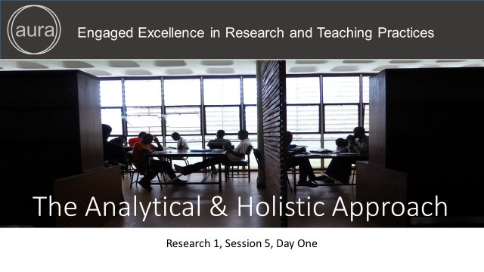
Points in bold are facilitation instruction - for example, they might indicate how to run a group discussion or brainstorming session.

Points in italic indicate things you should tell the audience. You can express them in your own words.

Underlined points refer to formative assessment techniques and indicate what you can learn from learner responses (although it is impossible to be comprehensive about all of the insights).

Slide 2
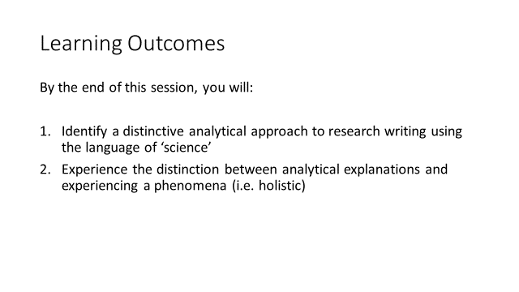
(2 min)
Facilitation: Introduce the learning outcomes of session 5 and explain to learners that the purpose of this session is to help them identify a distinctive analytical approach to research writing using the language of ‘science’, and thus experience the distinction between analytical explanations and experiencing a phenomenon.

Content: The purpose of this session is to help you identify a distinctive analytical approach to research writing using the language of ‘science’, and thus experience the distinction between analytical explanations and experiencing a phenomenon. The distinctive language of science reflects a highly analytical approach which breaks things down into discreet parts and hence is highly analytical and may be different from our experience of a phenomenon.

In this session we will focus on language and text, in contrast to the previous session during which we focused on visual imagery.
Formative Assessment: N/A

Slide 3
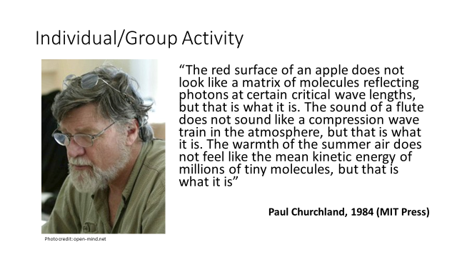
(Slide 3+4 = 10 min.)

Facilitation: Give learners some time to read the quote on the slide, and invite them to comment the quote by answering to the questions on the following slide. If the facilitator decided to have the quote on a slide and/or to read it aloud he/she might be aware of not stressing parts of the quote over others.

The facilitator might want to note that the quote is alluding to how we explain something and how we experience it. The quote might be confusing because it is actually combining the experience and the explanation of an apple; however; it is not elaborating on the experience. Experiencing something is different from explaining something.

Content: Take a few minutes to read individually on the quote on the slide by Paul Churchland (or on the handout titled "4 Paul Churchland") and reflect on the way he describes one way of observing a phenomenon. Please reflect on the quote by answering to the questions on the following slide. You will then be asked to share your thoughts with the group.

Formative Assessment: Individual reflection and group discussion during which learners would give and received constructive peer feedback.

Slide 4
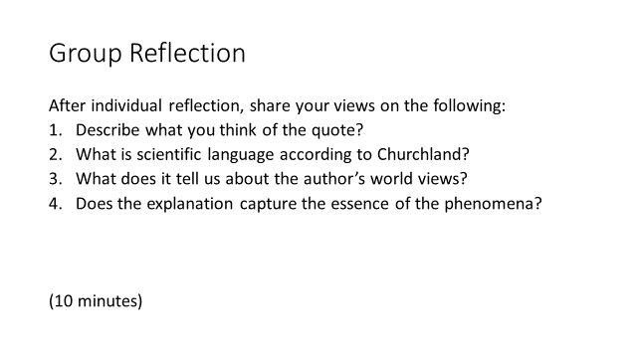
(Slide 3+4 = 10 min.)

Facilitation: the facilitator can find possible answers to some of the questions suggested for the reflective activity:

- What is scientific language according to P. Churchland? Possible answer: Scientific terms in the quote that represents the scientific language. There is terminology that has been devised within certain scientific disciplines to describe phenomena that are accepted
- What does it tell us about the author‘s worldviews? Possible answer: He is obviously a scientist but he is also showing to be quite articulate and reflective

After the group discussion reinforce that the purpose of the activity was to point to the difference between how we experience things and how we explain them in technical (or scientific) language. Finally, before moving on to the next activity, clarify that this activity was an example of applying high analytical scientific thinking which learners will explore further with the next activity.
Content: After individual reflection, share with the group your comments on the questions on the slide:
- In your own words describe what you think of the quote?
- What is scientific language according to P. Churchland?
- What does it tell us about the author‘s worldviews?
- Does the explanation capture the essence of the phenomena?

After the group discussion, I would like to reinforce that the purpose of the activity was to point to the difference between how we experience things and how we explain them in technical (or scientific) language. The orientation of the author reflects an analytical view of science yet his explanation lacks a richness of experience of the phenomenon. The explanation may lack some of the richness of experience and also how we may interpret an ‘apple’.
Before moving on to the next activity, I want to clarify that this is an example of applying high analytical scientific thinking which we will explore further with the next activity.

Formative Assessment: Individual reflection and group discussion (formative feedback). In order to have evidence of individual reflections, individuals could be asked to write down their short answers to the questions while during the reflection time. This would allow the facilitator to track learners’ improvement and provide individual feedback if necessary.

Slide 5
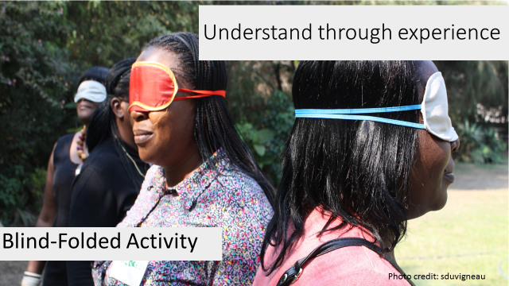

(5 to 10 mins)

Facilitation: Explain that this activity aims to make learners appreciate that knowledge can be derived from a subjective human experience and by experiencing a phenomenological approach. Remind them that so far they looked at two approaches to experiencing phenomena (i.e. visual and analytical approaches); now they will experience the process of ‘discovery’ using an unfamiliar topic to experience the phenomenological approach.

The experiential activity will apply methods that allow learners to reveal the essence of the process of an experience and the relationship with the phenomenological approach.

Phenomenology can be defined as having human experience as its object of research, but with it are inextricably linked a set of methods of going about the study of experience and theories about its nature. A phenomenological methodology is directed at studying variation in people’s ways of experiencing different phenomena.
Cartesian comes from Descartes’ philosophy that there is an external outcome reality and mind and body are separate as well as mind is separate from the external world. This is when we have started to objectify the external world and this strongly influences the scientific approach

Content: So far you looked at two approaches to experiencing phenomena (i.e. visual and analytical approaches). Now you will experience the process of ‘discovery’ using an unfamiliar topic to experience the phenomenological approach.
The experiential activity will apply methods that will allow you to reveal the essence of the process of an experience and the relationship with the phenomenological approach. The purpose of this session is to have you appreciate that knowledge can be derived from a subjective human experience.
Through emersion and a deep level of engagement in a holistic way, the exercise shows that the essence of a phenomenon may be revealed. This exercise is in comparison to an analytical approach that would be likely to apply pre-defined criteria to categorise, count and compare, contrast etc. criteria. From a philosophical perspective, this could be seen to reflect a non-Cartesian approach, which assumes a phenomenological lack of separation between the person and their world. The next activity will allow you to experience a phenomena. You will not apply a predefined framework or taxonomy for experiencing a phenomena. However, you will take a more analytical approach after lunch.

Formative Assessment: N/A

Slide 6
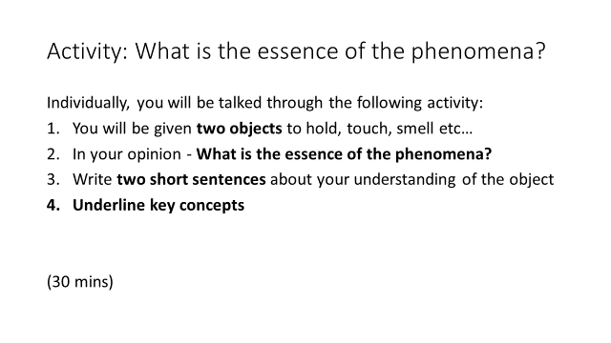
(30 mins)

Facilitation: Ensure that all the learners are blindfolded before handing out the objects. This may be a plastic rose and a cut rose flower, or maize or another plant. Invite learners to hold and touch the items quietly and enter into a process of enquiry where they try to understand the objects, by using their senses (10 min).

Note: the objects have to be one living and one artificial thing. Distribute post-it notes during the sensory exercise and then ask learners to remove their blindfolds and write two short sentences about their understanding of the objects e.g. the ‘live’ and plastic rose. The experience of sensing the two “flowers” without seeing them will enable learners to see that they are not “just two roses” but that they are fundamentally different. It enables people to connect with the objects and their qualities before applying preconceived categories or construct).

Content: You are going to be given two objects. Hold, touch, smell, taste the objects. What is the essence of the phenomena in your opinion?
Write two short sentences about the understanding of the objects underling key concept.

Before moving to the next exercise I would like to reinforce that this activity should have helped you reflect about the fact that: Engaging with both objects in this way can show how the artificial rose is an oversimplification (or [poor] imitation) of the real thing. The challenge to analytical approach is that we experience the objects in a different way from that expressed in Churchland quote.

Formative Assessment: Individual reflection and group discussion during which learners would give and received constructive peer feedback.

Slide 7
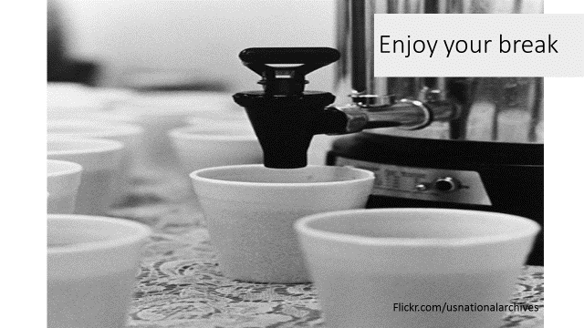

Slide 8
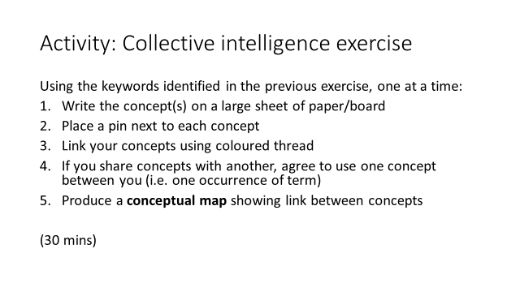
(Slides 8-9: total 40 mins)

Facilitation: Collective intelligence exercise - This collective intelligence exercise is divided into several parts: First is the Mapping, a tactile exercise that should take 20 mins. Clarify the instruction to the activity to the learners. At the end of the exercise the group will produce a conceptual map showing the link between concepts.

Content: In this activity you will learn to map concepts, and connect people’s conceptual maps, through a collective intelligence exercise. The exercise illustrates the inter-subjectivity of the group experience and the emergence of patterns based on individual sensing (emerging from the bottom up). We will learn how to do that using an experiential, participatory approach – which is an approach we will explore further in the R2 intervention. Come together as a group. You will create a network of concepts on a board using the underlined concepts defined by you. Share the concepts that describe the qualities of the objects e.g. ‘roses’ and show how to plot these concepts onto a board. Concepts should be:

- Write the concept on the large sheet of paper/board
- Place a pin next to each concept
- Link your concepts using a colour thread
- If you share concepts with another, agree to use one concept (i.e. there is only one occurrence and the shared terms connect the networks of concepts)
- Produce a conceptual map showing the link between concepts

The important point to note is that various techniques can be applied to capture and help illicit people’s knowledge of their experience, for example in the community. This kind of approach highlights the fact that people possess a rich understanding of their experience. Therefore, people can be viewed as expert with an intimate connection with a particular experience. Their insights are as valid as someone coming from the outside who might not comprehend their experiences in the same way. Hence this support the rationale for valuing and taking the time to illicit or to encourage people to explain how they see / experience a particular phenomenon. And this may be fundamental to your research.

Formative Assessment: Group discussions and shared learning with wider audience during which learners would give and received constructive peer feedback.

Slide 9
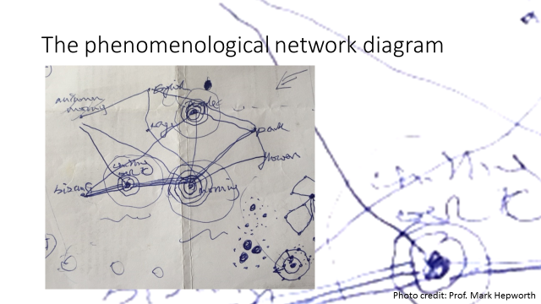

(Slide 8 to 9 = 30/max 40 min.)
See previous slide

Slide 10
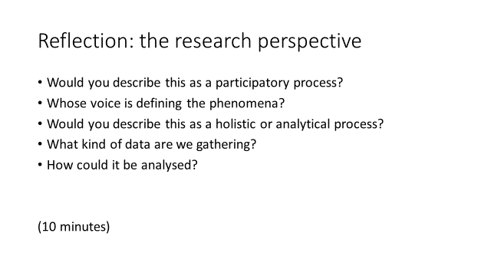
(10 min)

Facilitation: Learners are asked to reflect on the process they have just been through and answer the questions on the slide. Possible answers to some of the questions are suggested below:

- Would you describe this as a participative process? Possible answer: Yes, it highlights the value of a group of people who are non-experts and hence it makes sense to draw on their perceptions for a shared meaning making.
- Whose voice is defining the phenomena? Possible answer: The non-expert/the person who is an expert is the ones who is experiencing the phenomena
- What kind of data are we gathering? Possible answer: The data is a qualitative research approach. We searching for the essence and authenticity and not wanting to generalise across a population. However these insights may then be tested to a larger population, moving towards a more quantitative approach. As we have seen from the nodes where key terms are shared it could in fact be quantified to indicate certain patterns in the data.

Should learners require further support with this activity, the facilitator might think in more detail about the patterns and clusters that were emerging out of the data. How they could use quantification to help make sense of the data by counting the number of links to a node. Learners could also share this among groups to demonstrate that in fact there were common patterns across groups despite this being a very individual, subjective exercise of deriving data (i.e. highly qualitative). They could also discuss and introduce the concept or paradigm of phenomenological research. They might also touch on another phenomenography where people’s perceptions can be ordered in relation to each other in terms of zones of awareness.

The reflection could be individual as well as in pairs. If the time is limited, the facilitator could choose a few learners to have a sense of the answers in the room and assess whether further clarifications are needed.

After the discussion, the facilitator may reinforce the purpose of the activity.
Content: Reflect on the process that you have just been through and answer the questions on the slide:
- Would you describe this as a participative process?
- Whose voice is defining the phenomena?
- Would you describe this as a holistic or analytical process?
- What kind of data are we gathering?
- How could it be analysed?

I would like to highlight that each person contributed to the task of conceptualising an object. Each voice - the voice of the ‘non-expert’ - was valued. This highlights the value of listening to the voice of people who experience a situation in contrast to relying on the observations of an external ‘expert’.

An experiential, holistic understanding can be achieved through the use of your senses as well as critical thinking skills. This session hoped to have shown that participatory approaches can also be clustered and patterns may emerge (or be observed) in the same that you would analyse quantitative data.

Formative Assessment: If the reflective activity is done in pairs or groups, learners would give and received constructive peer feedback. If the reflection is individual, the facilitator is recommended to take the time to have a few learners sharing their reflections to provide feedback as well as to provide clarifications or answer questions if needed.

Slide 11

Slide 12

